**Dynamics of *Teleaulax* cryptophyte prey during red water blooms**

**in the Columbia River Estuary**

*Authors:*

Maria Hamilton 1,2, Gwenn M. Hennon 1,3, Joseph Needoba 4, Katie Maxey 4, Rhonda Morales 1, Tawnya D. Peterson 4, Megan Schatz 1, Jarred Swalwell 1, Peter Zuber 4, E. Virginia Armbrust 1, Francois Ribalet 1*

*Affiliations:*

1 School of Oceanography, University of Washington, Box 357940, Seattle, WA 98195 USA

2 Present address: Ocean Sciences Department, UC Santa Cruz, 1156 High Street, Santa Cruz, CA 95064

3 Lamont-Doherty Earth Observatory, Columbia University, 61 Route 9w, Palisades, NY 10964

4 Institute of Environmental Health, Oregon Health & Science University, 3181 SW Sam Jackson Park Rd., Portland, OR 97239 USA

* Corresponding author: ribalet@uw.edu

**ABSTRACT (250 words max)**

The mixotrophic *Mesodinium major* is a globally distributed nontoxic ciliate that produces red-colored blooms using chloroplasts from its cryptophyte prey, *Teleaulax amphioxeia.* Little is known about the ecology and physiology of the *T. amphioxeia* prey and how their growth influences the initiation and development of *M. major* blooms. To better understand how environmental factors influence the population dynamics of *T. amphioxeia*, a 4-week survey was conducted in the Columbia River estuary in 2013 during which abundances and division rates of the cryptophytes were continuously monitored using flow cytometry. The highest abundance of free-living *T. amphioxeia* occurred during the first neap tide with concentrations as high as 1.8 x 106 cells L-1 and decreased during spring tide and later neap tides (< 0.5 x 106 cells L-1). A 10-fold variation in cryptophyte cell abundance occurred daily, which was not associated with the daily tidal cycle or the spring/neap tide cycle. Cryptophyte division rates, predicted *in situ* here for the first time, ranged from 0.2 to 1.5 d-1, with the highest values observed in accordance with high abundances of *T. amphioxeia.* These division rates were positively correlated with concentrations of dissolved inorganic nitrogen and phosphorus, suggesting nutrient limitation of cryptophyte cells in the Columbia river estuary rather than light limitation, as previously thought. Calculations of *T. amphioxeia* production compared to *M. major* abundances showed that the growth of the ciliate may have been limited by prey availability. Furthermore, the low abundances of free-living prey are inconsistent with the detection of numerous (> 20) *T. amphioxeia* within *M. major*, suggesting for instance a long retention time or replication of the prey within the ciliate.

Key words: cryptophytes; *Teleaulax; Mesodinium;* growth rates.

**INTRODUCTION**

The common coastal ciliate, *Mesodinium major*, previously included in the *Mesodinium rubrum* (*Myrionecta rubra*) (Lohmann 1908, Jankowski 1976) species complex (Garcia-Cuetos et al. 2012), is among the marine microzooplankton that temporarily maintains the plastids of their cryptophyte algal prey, *Teleaulax amphioxeia* (Herfort et al. 2011b). This association allows the ciliate to function as a mixotroph, capable of utilizing both phagotrophy and photosynthesis to acquire carbon (Crawford 1989). Although *M. major* populationsare important primary producers in many coastal and estuarine systems (Stoecker et al. 1989, Herfort et al. 2012), little is known about the ecology and physiology of the *T. amphioxeia* prey and how their growth and abundance may influence bloom dynamics.

Massive *M. major* blooms occur each summer in the Columbia River estuary (CRE) (Herfort et al. 2011a). The blooms persist for several weeks during the late summer and early fall, and shift the trophic status of the estuary from net heterotrophic to net autotrophic (Herfort et al. 2012). The annual *M. major* bloom appears to be initiated during summer neap tides (Herfort et al. 2011a), when both tidal forcing and the seasonality of freshwater discharge result in an extended summer saltwater intrusion (Chawla et al. 2008). The blooms appear to start in Baker Bay, where a shallow depth and long water retention time favor the persistence of high cell abundances (>100 cells mL-1) and fast division rates (1.2–3.1 d-1) of *M. major*. Within a few weeks, the initial blooms spread throughout the main estuary (Herfort et al. 2011a). A decline in the abundance of small (<5 µm), free-living *Teleaulax* cells coincided with an increase in *M. major* abundance observed in the CRE in 2011 (Peterson et al. 2013), suggesting a direct link between consumption of the cryptophyte prey and the initiation of *M. major* blooms. Further evidence of a connection between prey populations and the development of *Mesodinium* blooms was observed in an Antarctic saline lake, where an increase in the abundance of cryptophytes preceded the increase in abundance of *M. rubrum* (van den Hoff et al. 2015). However, the factors that influence cryptophyte prey population dynamics remain poorly understood in these systems, and the underlying mechanisms linking ciliate and prey populations are unclear. For example, does the cryptophyte population size influence bloom initiation in *Mesodinium* in a predictable way? Does the physiological status of cryptophyte prey (as indicated by division rate rather than population size) influence development of *Mesodinium* blooms?

In order to investigate the influence of prey population size and physiological status on initiation and development of *Mesodinium* blooms, it is important to identify patterns in population growth rates (or cell division rates) for the organisms of interest. Numerous factors that influence cell abundances, including rates of cell division and cell mortality, and physical advective transport. In a dynamic system such as the CRE, a continuous sampling approach must be applied in order to capture changes in abundances over time. Continuous measurements of the population size structure can be used to estimate division rates based on changes in cell size distribution over the course of a day (Sosik et al. 2003, Hunter-Cevera et al. 2014, Ribalet et al. 2015). This new method eliminates many of the difficulties and biases associated with the determination of cell division rates using discrete sampling techniques (Laws 2012).

Here, we apply a continuous approach for the determination of cryptophyte abundances and division rates both in the laboratory and in the field using the continuous flow cytometer, SeaFlow (Swalwell et al. 2011). We identified relationships between abundances and division rates of *T. amphioxeia* and environmental variables as well as abundances of *M. major.* We carried out a 4-week survey in 2013 in which dissolved nutrient concentrations, salinity, temperature, light irradiance, and abundances of cryptophytes and *M. major* were determined during red water blooms in the CRE. Daily division rates of cryptophytes were calculated from the change of size distribution over a 24-h period using a size-structured division rate model (Ribalet et al. 2015). The abundance and division rates of cryptophyte populations were compared with abundances of *M. major* to determine the influence of prey physiology and abundance on red water bloom formation.

**METHODS**

**Study Area**

Samples were collected at 2.4 m depth for 1 month, 4 days a week, from September 11th to October 2nd 2013 using a continuous seawater flow-through system at SATURN-03, a fixed station located at the end of a dock in Hammond, OR (**Fig. S1**) (Baptista et al. 2015). Discrete samples were also collected during the turn of the high tide (i.e., at slack water).

**Hydrological conditions**

Water temperature, salinity and pH were measured continuously at SATURN-03 using a SeaBird <model> Conductivity-Temperature (CT) meter for temperature and salinity, and a Durafet pH sensor (Honeywell). Photosynthetic Active Radiation (PAR) data were obtained from Desdemona Sands Light mooring, located 3 km north of SATURN-03.

**Nutrient concentrations**

30 mL water samples for nutrient analysis were taken in duplicate.

JN writes this

**Determination ofcryptophyte cell abundance and cell size**

Continuous measurements of cryptophyte abundances and cell size were made using SeaFlow, (Swalwell et al. 2011). The instrument was equipped with a 457-nm 300-mW laser (Melles Griot). Forward light scatter (a proxy for cell size), red, and orange fluorescence were collected using a 457–50 bandpass filter, 692–40 band-pass filter, and 572–27 bandpass filter, respectively. Seawater was prefiltered through a 100-µm stainless steel mesh (to eliminate large particles) prior to analysis. The flow rate of the water stream was set at 15 mL min−1 through a 200-µm nozzle for the field and laboratory experiments. A programmable syringe pump (Cavro XP3000, Hamilton Company) continuously injected fluorescent microspheres (1 µm, Polysciences) into the water stream as an internal standard. Files were written every three minutes. Data were analyzed using the R package *Popcycle* version 0.2, which uses a SQLite relational database management system to retrieve flow cytometry data (<https://github.com/uwescience/popcycle>). A sequential bivariate manual gating scheme was used to cluster the cryptophyte population based on orange fluorescence and forward light scatter measurements.

To confirm the identification of cryptophyte cells, discrete samples for flow cytometry were collected once a day during slack tide, fixed with 0.025% glutaraldehyde and stored at -80 ºC. Six months after sample collection, fixed samples were analyzed with a BD Influx cell sorter equipped with a 488-nm 200-mW laser (Coherent). 100 cells from the gated population with high orange fluorescence and high forward light scatter (assumed to represent phycoerythrin-containing cryptophytecells) were sorted onto a glass slide. The cells were then examined under a Nikon Eclipse 80i epifluorescence microscope at 400x magnification and photographed using a Qimaging MicroPublisher 3.3 RTV camera.

We estimated cryptophyte cell size using an empirical relationship between light scatter measured by SeaFlow and cell size measured by a Coulter Counter for different exponentially growing phytoplankton cultures of cell sizes ranging from 1 to 10 μm (Ribalet et al. 2015).

**Estimates of cryptophyte cell division rates**

*Laboratory culture validation*

A non-axenic culture of the cryptophyte *Rhodomonas* sp. (CCMP 755) was grown in the laboratory in natural seawater amended with f/2 nutrients at 13 °C with a 16:8 light-dark cycle of 100 µE m-2 s-1 provided by white fluorescent tubes. The culture was grown for 4 d in a 20-L batch culture and continuously mixed with a magnetic carboy stir bar. A peristaltic pump (Peri-Star Pro, World Precision Instruments) collected samples at a rate of 15 mL min−1 for 15 min every hour for measurement with SeaFlow. On day 3, 1 mL samples of the culture were collected in triplicate every 2 h for 28 h, fixed with 0.01% glutaraldehyde and stored in liquid nitrogen for cell-cycle analysis. One month after sample collection, fixed samples were stained with green-fluorescing DNA stain SYBR Green I (diluted with dimethylsulfoxide) at a final concentration of 0.01% for 15 min at room temperature in the dark. Following the addition of fluorescent microspheres (1 μm, Polysciences) used as an internal standard, stained samples were analyzed with a BD Influx flow cytometer. Data were obtained using the *Spigot Operating Software* version 5.0 (BD Biosciences) and analyzed using *FlowJo* version 9.7.2 (Tree Star). At least 10,000 cells werecollected per sample. DNA frequency distributions were analyzed using the *FlowJo* cell cycle platform to obtain cell fractions in G1, S, and G2+M phases. Division rates based on DNA distributions were computed as described previously (Carpenter and Chang, 1988), based on the following equation:

$μ_{DNA}=\frac{1}{(n×t_{S+G2+M})}×\sum{ln⁡[1+f_{s+G2+M}\left(i\right)]}$

where n is the number of samples taken during the 24-hr period, *t*S+G2+M combined duration of S and G2+M phases, and *f*S+G2+M(i) is the fraction of cells in S and G2+M for sample *i*. The duration of S and G2+M phases was estimated as twice the distance between the peak of cells in phase S and the peak of cells in the G2+M phase. Cell-cycle based estimates of division rates were then compared with size-structure modeled division rates.

*Size-structured matrix model*

We used a size-structured matrix population model developed by Sosik et al. (2003) to estimate cryptophyte population division rates. The model represents changes in cell sizes over a diel cycle and can be fit to time series of cell size distribution. The fitted model provides an estimate of the daily division rate independently from cell abundance. We implemented Sosik’s original Matlab model in an R package *ssPopModel* version 0.1.1, available on Github (<https://github.com/armbrustlab/ssPopModel>). The model is based on the assumptions that 1) cell growth is determined by light exposure, with other abiotic factors such as nutrient availability and temperature operating at longer time scales, 2) the probability of a cell dividing depends on size, 3) all cells within a discrete size class have the same probability to change to another size class, and 4) a cell divides into two daughter cells, each half the size of the mother cell. The model predicts the cell size distribution over the course of the day using the cell size/cell division relationships and the light-dependence of cell division. Daily-averaged division rates were calculated as the sum of hourly division rates over a 24-h period.

**Cryptophyte community composition**

*DNA extraction*

Sample volumes of 0.5-2.0 L were filtered with a 20 μm filter followed by a 0.2 μm Sterivex filter. The size fractionation was performed to separate the *Teleaulax* symbiont in *M. major* cells from free living *Teleaulax.* Filters were fixed with 2 mL of RNAlater and stored at -80°C until extraction. DNA were extracted using the CTAB method (Li et al. XXXX). Briefly, the filters are suspended in buffer and proteinase K in 2 mL microcentrifuge tubes and incubated at 55 °C overnight. After this incubation, 165 μL each of 5M NaCl and 10% CTAB were added and incubated for an additional 10 min at 55°C. Approximately 600 μL of chloroform was added and the samples were then vortexed for 75 s, followed by centrifugation (13,000g) for 10 min. The DNA of the aqueous layer was purified using a DNA Clean and Concentrate Kit (Zymo Research). The total extracts were stored at -20°C until further use.

*Identification of the cryptophyte nuclear 28S D2 unique sequence element*

A specific genetic marker was used to distinguish between *T. amphioxeia* and other free-living cryptophytes. This marker is the Unique Sequence Element (USE) found in the D2 region of the LSU (28S) rRNA sequence. The cryptophyte nuclear D2 region of the LSU was identified using the 28S D1-D5 sequence for the cryptophyte *Goniomonas truncata* (accession number FJ176709). A BLASTn search showed a large gap in sequence homology of around 300-400 bp near the 5’ end of the LSU. Primers were designed using Primer-BLAST to flank this gap region (crp28SF CTTGCTTGGGAATGCAGGTC /crp28SR TACGAGCCTCCACCAGAGTT). These primers were used with PCR to amplify the LSU D2 of *Teleaulax*.Single-cell PCR was performed on *M. major* cells from red water in the CRE collected in 2011 and 2014. The laboratory culture of an Antarctic strain of *M. rubrum* (CCMP2563) was used as a control, as it is fed with the cryptophyte *Geminigera cryophilia* (CCMP 2564)*.* The PCR protocol for the LSU D2 sequence identification was as follows: initial denaturation at 95 °C for 3 min; 35 cycles of denaturation at 95 °C for 45 s, annealing at 50 °C for 40 s, and extension at 70 °C for 2 min; and a final extension at 70 °C for 7 min. The resulting PCR products were visualized on a 1% agarose gel. The PCR products were purified (UltraClean PCR clean up kit, MoBio), ligated into a TOPO 2.1 vector (Invitrogen), and transformed into chemically competent *E. coli* cells (DH5α strain). The transformed cells were grown up overnight at 3 7°C on LB plates containing 40 μg mL-1 X-gal and 50 μg mL-1 Kanamycin. White colonies were selected and grown up overnight in a 37 °C water bath shaker in 2X YT broth with 50 μg mL-1 Kanamycin. Miniprep (FastPlasmid Mini Kit, 5 Prime) was performed and the samples were sent to the Molecular and Cellular Biology Core of the ONPRC for sequencing. Sequences of around 650 bp were assembled and aligned using *Geneious* software version XXX.

Alignment between the *T. amphioxeia* and *G. cryophilia* D2 sequences identified a unique sequence element (USE) (Kahn et al. 2014) of around ~ 220 bp. The *T. amphioxeia* USE was used as a species specific marker to track the free-living cryptophyte and *M. major* in the estuary. The specificity of the USE was demonstrated using FISH on red water and lab culture samples. A FISH probe labeled with the fluorophore Alexa488 [TxD2 FISH (Alexa 488 – AACACACGAGTTAAGATACCAATGGATCATTCACTCGCATGCCC)] was designed to hybridize to the 3’ end of the USE in *T. amphioxeia*. The probe was labeled with Alexa488 fluorophore. The probe was seen in the cytoplasm of both the ciliate and free cryptophytes in red water samples, but not in the laboratory *M. rubrum* culture.

The 28S D2 sequence was extended to the 3’ end of the 18S rRNA using the general eukaryotic 18S primer BMB-CR (GTACACACCGCCCGTCG)to Crp28SR. This region includes the 5S and ITS2. The 18S rRNA sequence generated was identical to that of *T. amphioxeia*.

*Real Time PCR*

The distribution and size of cryptophyte populations and of the specific prey populations (*T. amphioxeia*) were monitored in environmental samples by qPCR. Quantitative PCR was performed on a StepOnePlus Real Time PCR system (Life Technologies) using SYBR Green as the reporter dye and the following protocol: initial denaturation at 95 °C for 10 min; 40 cycles of denaturation at 95°C for 15 s, and extension and data acquisition at 60 °C for 1 min; followed by a melting curve analysis. The *T. amphioxeia* specific primers [TxD2 1F (TGAAAAAGGGCCTGAAATTG) /TxD2 USE 2R (ATCATTCACTCGCATGCCCC)] were used to amplify the USE of the prey cryptophyte. General cryptophyte primers targeting sequences from a region downstream of the USE [CrpSpecf 3F (GTTCTGAAGATGCTGGCACA)/ CrpSpecf 3R (GTTCTGAAGATGCTGGCACA)] were used to monitor total cryptophyte populations and calculate the ratio of amplicons from *T. amphioxeia* to total cryptophytes. This sequence was downstream of the USE. Primers were designed using Primer-BLAST from NCBI and confirmed with PCR.

The Antarctic *M. rubrum* culture was used as a control (i.e., negative for prey-specific and positive for general-cryptophyte sequences). All environmental total extracts were diluted 10-fold before analysis to reduce concentrations of interfering compounds. All standards, samples and water blanks were analyzed in triplicate and 1 μL of DNA template was used in each reaction. Standards for qPCR were constructed with the *T. amphioxeia* LSU D2 region cloned into a TOPO 2.1 vector. This plasmid was used for both primer sets as it contained the *T. amphioxeia* specific USE and general cryptophyte sequences. A standard curve was generated from six standards with concentrations ranging from 9.289 x 106 – 9.289 x 101 D2 copies µL-1. Concentrations of the standards were calculated from Kahn et al. (2014). Concentrations of USE copies were determined with the following formula:

$Copies {mL}^{-1}=\frac{c × v ×d}{V}$

Where *c* is the copies μL-1 determined from qPCR, *v* is the volume in μL the extracted DNA was re-suspended in, *d* is the dilution factor and *V* is the volume in mL of the water sample.

***Mesodinium major* cell abundance**

45 mL samples fixed with a final concentration of 0.5% glutaraldehyde were collected into 50 mL centrifuge tubes for *M. major* counts and stored at -20 °C pending analysis. Prior to analysis, the samples were slowly thawed to 4 °C and analyzed using an imaging flow cytometer (FlowCAM, Fluid Imaging, Inc.). A minimum of 1000 particles with diameter >5 m was captured and the images were filtered using *VisualSpreadsheets* software version 3.1 (Fluid Imaging, Inc.) according to size. Those resembling *M. major* were selected based on visual inspection and enumerated. Flow rates were calculated using *VisualSpreadsheets* software, allowing for the quantification of cellular abundances.

**RESULTS**

**Environmental conditions**

The Columbia River estuary is a turbid and often highly stratified system characterized by its dynamic physical processes, short residence time (0.5-5 d), and strong influence from diurnal and semi-diurnal tides (Neal 1972, Jay 1984). Throughout the 4-week survey at SATURN-03 (**Fig. S1**), surface water temperature and salinity were anti-correlated and oscillated with the tidal cycle, with high tide characterized by an influx of colder, saltier water from the Pacific Ocean, and low tide characterized by an increase in warmer, fresher water from the Columbia River (**Fig. 1A**). The survey began and ended during neap tides (day 1-4, day 15-25). The spring tide, which occurred during the second week of the survey (day 7-11), coincided with the largest oscillations in surface water salinity and temperature observed during the survey. The lowest average salinity was observed on the last neap tide (day 23-25), with little variation in temperature over the tidal cycle (**Fig. 1A**). The average surface water temperature and salinity during the survey was 17.5 °C and 12 psu, respectively.

Surface pH ranged from 7.8 to 8.4 and was correlated with tidal cycles (measured as water elevation), with higher values corresponding to flood tides (**Fig. 1B**). The lowest pH values were observed at day 3 and increased progressively during the survey. Concentrations of dissolved inorganic phosphate (DIP) and nitrogen (DIN as the sum of nitrate, nitrite and ammonium) were relatively high during the survey (> 5 µM and > 0.4 µM for DIN and DIP, respectively), with the highest values observed at day 7, which coincided with the start of the spring tide. DIP and DIN concentrations co-varied throughout the survey (**Fig. 1C**) and were negatively correlated with pH (R = 0.69 and 0.58, p< 0.05, respectively) (**Fig. S2**).

Total chlorophyll *a* fluorescence, a proxy for phytoplankton biomass, was low during neap tides (week 1, 3 and 4), and increased to its highest values during spring tide (week 3) (**Fig. 1B**). A positive correlation between chlorophyll *a* fluorescence and tidal cycle was observed during the survey (R = 0.58, p < 0.001), with high values increasing during flood tide. Chlorophyll *a* fluorescence was not correlated with pH, DIN or DIP.

**Cell abundances**

Fixed samples of the putative cryptophyte populations with characteristic size and orange fluorescence were examined under a light microscope after sorting with a BD Influx flow cytometer. The small size (<5 µm in length) and teardrop shape of the cells (**Fig. S3**) corresponded with past observations of *Teleaulax amphioxeia* cells (Peterson et al. 2013). We therefore assumed that the cryptophyte cell population measured by the SeaFlow represented a *T. amphioxeia* population during the survey. Surprisingly, the contribution of *T. amphioxeia* to the total cryptophytes determined by qPCR was always less than 1% (0.06% to 0.40%), with the highest and lowest percentages of *T. amphioxeia* occurring during the first and second week of the survey, respectively (**Table 1**). This result suggested that > 99% of cryptophyte detected by qPCR was not quantified by the cytometer, probably because most cryptophyte cells were larger than the size range of the SeaFlow instrument (0.5 to 15 µm).

Hourly-averaged cell abundances of *T. amphioxeia*-like cells measured continuously by flow cytometry ranged from 0.02 x 106 to 1.8 x 106 cells L-1, with an average of 0.29 x 106 cells L-1 (**Fig. 2**). Cell abundances obtained with the SeaFlow were in excellent agreement with discrete samples analyzed by conventional flow cytometry (R2 = 0.83, p < 0.01, **Fig. S4**). The highest abundances were observed during the first two days of the first neap tide, with a daily averaged abundance of 0.52 x 106 cells L-1, (**Fig. 2A**). The spring tide (days 7-10) and second neap tide (days 15-18) exhibited the lowest abundances, with an average of 0.08 x 106 cells L-1 and 0.09 x 106 cells L-1, respectively (**Fig. 2B and C**). Although variations in cell abundance change rapidly over a few hours, changes in the abundance of *T. amphioxeia*-like cells did not coincide with daily tidal cycle or spring/neap tide cycle.

The abundances of *M. major* (measured only once a day at high-tide) were on the same order of magnitude*,* but typically lower than abundances of *T. amphioxeia*-like cells, with values varying from 0.021 x 106 to 0.32 x 106 cells L-¹ during the survey (**Fig. 2**). A positive correlation between abundances of cryptophytes and *M. major* was observed during the survey (R = 0.71, p < 0.01) (**Fig. 3**). Abundances of *M. major* and *T. amphioxeia*-like cells were not significantly correlated with environmental conditions such as salinity, nutrient concentrations or spring/neap tide cycle during the survey (data not shown).

**Division rates**

To establish the accuracy of the method, we compared size-based estimates of division rates (h-1) with cell-cycle based estimates of division rates for the cryptophyte *Rhodomonas*. The hourly division rates estimated using both cell cycle analysis and the model followed the same general trend throughout the experiment (**Fig.** **4**), although some discrepancies occurred around dawn (at hour 1, 3 and 27). The coefficient of determination R2 = 0.60 (p < 0.001) (**Fig.** **S5**) indicated that the model provided reasonable estimates of division rates for the cryptophyte *Rhodomonas* in culture*.* In the field, our limited access to the sampling site prevented the use of the cell-cycle method to validate our model-based estimates of division rates for the cryptophyte population. During the entire survey, the median size of the cryptophyte population increased during daylight and decreased at night, regardless of the tidal cycle (**Fig.** **5A**), which is consistent with the model assumptions that photosynthesis and cell division are the main factors influencing the change of cell volume over a 24-h period (Sosik et al. 2003).

Estimates of the daily division rates of cryptophyte population during the survey ranged from 0.2 ± 0.1 d-1 to 1.5 ± 0.1 d-1 (**Fig. 4**), which correspond to 0.3 and 2.1 division per day, respectively. The highest division rate was observed at day 3 and coincided with the lowest pH values (**Fig. 2C**). Division rates were positively correlated with concentrations of dissolved inorganic nutrients (R = 0.66 and 0.55, p < 0.05, for DIP and DI, respectively) and negatively correlated with pH during the survey (R = -0.64, p < 0.05) (**Fig. S7**), with decreasing division rates observed with daily-averaged pH > 8.0. No significant correlation was observed between division rates and other environmental factors, such as temperature (data not shown).

**DISCUSSION**

**Ecophysiology of the *Teleaulax amphioxeia*** **during the survey**

The cryptophyte *Teleaulax amphioxeia* is a cosmopolitan marine species that is widely distributed in coastal habitats worldwide. During our survey, no consistent increase in cryptophyte cell abundance was observed with seawater intrusion, and variations in abundances were not directly related to the daily tidal cycle or spring/neap tide cycle. The lack of a relationship between cryptophyte cell abundance and salinity is in direct contrast with our measurements of red fluorescence, which suggested that seawater intrusions bring into the estuary many phytoplankton cells of marine origin. Cryptophyte abundances shifted dramatically over the course of just a few hours. These results suggest that *T. amphioxeia* distribution is very patchy within the CRE, and highlight the importance of physical transport in the dynamics of *T. amphioxeia* in the estuary. Such variability in cell abundance should be taken into consideration when interpreting results from abundance data extrapolated from a small number of data points, and emphasizes the importance of continuous measurements for monitoring phytoplankton in the CRE.

To the best of our knowledge, this study is the first to estimate division rates of cryptophyte species in the field. These estimates are based on a size-structured matrix model that assumes that cells can only grow via photosynthesis and not by other processes, such as phagotrophy. We confirmed that the size-structured matrix model accurately predicts division rates for the cryptophyte, *Rhodomonas sp.* grown under laboratory conditions (**Fig. S6**). Additionally, we observed that cryptophyte populations increased mean cell volume only during daylight and decreased mean cell volume at night, consistent with the model assumption that photosynthesis is the main factor driving the growth and division of the population over a diel cycle.

The highest estimates of cryptophyte division rates reached 1.5 d-1 during the survey (day 3), which is consistent with *T. amphioxeia* isolates grown in the laboratory under nutrient replete conditions (Nishitani et al. 2008, Berge et al. 2010, Rial et al. 2012), suggesting that cells at that time were growing near optimal growth conditions. Division rates of the cryptophyte during the survey were positively correlated with nutrient concentrations and negatively correlated with pH (Fig. S6). A direct negative effect of pH on the division rates of *T. amphioxeia* during the survey is unlikely considering that a previous study showed that their growth was only affected by pH values below 6.5, with no significant effect at higher pH values (Berge et al. 2010). One parsimonious hypothesis for this apparent discrepancy could be that nutrient availability was limiting the growth *T. amphioxeia* during the survey, while high pH values would be the results of XX The potential effect of nutrient availability on *T. amphioxeia* growth is unexpected in the turbid waters of the Columbia River estuary, where light is generally considered to be an important factor limiting phytoplankton growth (Small et al. 1990). No significant correlation between irradiance and *T. amphioxeia* division rates was observed during the survey (data not shown), which support previous studies that hypothesized that the photosynthetic machinery of cryptophytes is well adapted to low-light conditions (Bergman et al. 2004).

**Influence of *Teleaulax* cryptophyte abundances on *M. major***

The abundances of *T. amphioxeia-*like cells were comparable to those of *M. major* **(Fig. 3)**. Assuming ingestion rates between ~3.5 and 8.9 cryptophytes ciliate-¹ day-¹ by *M. major*, with a minimum of ~1 cryptophyte ciliate-¹ day-¹ needed for maximum growth (Yih et al. 2004, Hansen and Fenchel 2006), the results would indicate that abundances of free-living *T. amphioxeia* were too low to sustain the growth of *M. major* during the survey. The calculations of average daily *T. amphioxeia* production support our hypothesis that the prey availability was limiting the growth of the ciliate during the survey. Using a FISH probe for the *T. amphioxeia* 28S DNA, up to >20 *T. amphioxeia* cells were observed within a single *M. major* cell (P. Zuber, unpublished data). Given the low abundances of free-living *T. amphioxeia*, its prevalence within *M. major* cells during red water blooms suggest that the development of *M. major* does not rely solely on the availability of free-living *T. amphioxeia*.

There are a few different possible phenomena that could potentially explain the ability for *M. major* to proliferate in the estuary with a high number of internal prey, despite the relative lack of free-living *T. amphioxeia*. The most parsimonious explanation would be that *T. amphioxeia* is able to persist inside the ciliate as a non-replicating endosymbiont for an extended period of time, and grows in number over the course of the bloom as *M. major* continues to graze. In the Korean isolate of the related ciliate, *M. rubrum*, it has been shown that the prey plastids can not only persist, but also maintain photosynthetic function for up to 80 days (Myung 2013). Though the perseverance of whole endosymbionts in *Mesodinium* ciliates has yet been investigated in full, it is possible that *T. amphioxeia* could remain inside *M. major* for at least as long as it would take for the ciliate to acquire enough prey as seen in the present study. The high number of internal *T. amphioxeia* could also potentially be explained by replication of the cryptophyte inside the host cell. While the ability of *T. amphioxeia* to divide inside *M. major* has not yet been demonstrated in cultures, it has been observed in other single-celled endosymbiont-bearing organisms, such as the ciliate *Paramecium bursaria* (Kodama and Fujishima 2009, Johnson 2011). Another possible explanation could be related to the observations of numerous cryptophytes attached to the cirri of *M. major* during previous blooms in the CRE (Peterson et al. 2013). These attached cryptophytes, neither free-living nor endosymbionts, would not have been detected by the methods used in this study and could potentially represent the “missing” source of prey for *M. major*.

Any one of these possible explanations for the differences observed between the number of free-living and ingested *T. amphioxeia* would represent a deviation from the canonical descriptions of predator-prey relationships between marine microbes. It is clear that, while environmental conditions (such as nutrient availability) affecting the abundances and physiology of *T. amphioxeia* are likely to play a significant role in the development of the *M. major* bloom, the unique interactions between this ciliate and its cryptophyte prey also contribute to *M. major*’s proliferation in the CRE. Without a cultured representative of *M. major*, the specifics of this predator-prey relationship remain speculative. Future studies would benefit from the combined use of molecular methodologies and high-resolution sampling to examine the interactions between the captured *T. amphioxeia* and *M. major*, *in situ*.

**Acknowledgments**

All the SeaFlow fans without whom life would be meaningless.

CMOPers, Michael Wilkins and co.

**References**

Baptista AM, Seaton C, Wilkin MP, Riseman SF, Needoba JA, Maier D, Turner PJ et al. (2015) Infrastructure for collaborative science and societal applications in the Columbia River estuary. Frontiers of Earth Science 9:659-682

Berge T, Daugbjerg N, Andersen BB, Hansen PJ (2010) Effect of lowered pH on marine phytoplankton growth rates. Marine Ecology Progress Series 416:79-91

Bergman T, Fahnenstiel G, Lohrenz S, Millie D, Schofield O (2004) The impacts of a recurrent resuspension event and variable phytoplankton community composition on remote sensing reflectance. Journal of Geophysical Research 109: 1–12

Carpenter E, Chang J (1988) Species-specific phytoplankton growth rates via diel DNA synthesis cycles. I. Concept of the method. Marine Ecology Progress Series 43:105-111

Chawla A, Jay D, Baptista J, Wilkin, Seaton (2008) Seasonal variability and estuary-shelf interactions in circulation dynamics of the river-dominated estuary. Estuaries and Coast 31:269-288

Crawford D (1989) *Mesodinium rubrum*: the phytoplankter that wasnʼt . Marine Ecology Progress Series 58:161-174

Hansen PJ, Fenchel T (2006) The bloom-forming ciliate *Mesodinium rubrum* harbours a single permanent endosymbiont. Marine Biology Research *2*:169-177

Herfort L, Peterson TD, Campbell V, Futrell S, Zuber P (2011) *Myrionecta rubra* (*Mesodinium rubrum*) bloom initiation in the Columbia River estuary. Estuarine, Coastal and Shelf Science 95:440-446

Herfort L, Peterson TD, McCue LA, Crump BC, Prahl FG, Baptista AM, Campbell V, Warnick R, Selby M, Roegner GC, Zuber P (2011) *Myrionecta rubra* population genetic diversity and its cryptophyte chloroplast specificity in recurrent red tides in the Columbia River estuary. Aquatic Microbial Ecology 62:85-97

Herfort L, Peterson TD, Prahl FG, McCue LA, Needoba JA, Crump BC, Roegner GC, Campbell V, Zuber P (2012) Red Waters of *Myrionecta rubra* are Biogeochemical Hotspots for the Columbia River Estuary with Impacts on Primary/Secondary Productions and Nutrient Cycles. Estuaries and Coasts 35:878-891

Hunter-Cevera KR, Neubert MG, Solow AR, Olson RJ, Shalapyonok A, Sosik HM (2014) Diel size distributions reveal seasonal growth dynamics of a coastal phytoplankter. PNAS 111(27): 9852–9857

Jay DA (1984) Circulatory processes in the Columbia River Estuary. Columbia River Estuary Study Taskforce, Astoria, OR

Johnson MD (2011) The acquisition of phototrophy: adaptive strategies of hosting endosymbionts and organelles. Photosynthetic Research 107:117-132

Kahn et al.

Kodama Y, Fujishima M (2009) Timing of perialgal vacuole membrane differentiation from digestive vacuole membrane in infection of symbiotic algae Chlorella vulgaris of the ciliate Paramecium bursaria. Protist 160:65–74

Laws 2012

Li et al.

Lohmann H (1908) Untersuchungen zur Feststellung des vollstandigen Gehaltes des Meeres an Plankton. Wiss. Meeresunters. 10: 129-370

Neal VT (1972) Physical aspects of the Columbia River and its estuary. In: Pruter AT, Alverson DL (eds) The Columbia River estuary and adjacent ocean waters. University of Washington Press, Seattle, WA, p 19–40

Nishitani G, Nagai S, Takano Y, Sakiyama S, Baba K et al (2008) Growth characteristics and phylogenetic analysis of the marine dinoflagellate Dinophysis infundibulus (Dinophyceae). Aquat Microb Ecol 52:209–221

Peterson TD, Golda RL, Garcia ML, Li B, Maier MA, Needoba JA, Zuber P (2013) Associations between *Mesodinium rubrum* and cryptophyte algae in the Columbia River estuary. Aquatic Microbial Ecology 68:117-130

Rial P, Garrido JL, Jaén D, Rodríguez F (2013) Pigment composition in three Dinophysis species (Dinophyceae) and the associated cultures of Mesodinium rubrum and Teleaulax amphioxeia. Journal of Plankton Research35:433-437

Ribalet F, Swalwell J, Clayton S, Jiménez V, Sudek S, Lin Y, Johnson ZI, Worden AZ, Armbrust EV (2015) Light-driven synchrony of Prochlorococcus growth and mortality in the subtropical Pacific gyre. PNAS 112:8008-8112

Small (1990)

Sosik HM, Olson RJ, Neubert MG, Shalapyonok A (2003) Growth rates of coastal phytoplankton from time-series measurements with a submersible flow cytometer. Limnology and Oceanography 48:1756-1765

Stoecker DK, et al. (1989) Abundance of autotrophic, mixotrophic, and heterotrophic planktonic ciliates in shelf and slope waters. Marine Ecology Progress Series 50:241-254

Swalwell JE, Ribalet F, Armbrust EV (2011) SeaFlow: A novel underway flow-cytometer for continuous observations of phytoplankton in the ocean. Limnology and Oceanography: Methods 9:466-477

van den Hoff J, Bell, E (2015) The ciliate Mesodinium rubrum and its cryptophyte prey in Antarctic aquatic environments. Polar Biology 38:1305-1310

Yih W, Kim HS, Jeong HJ, Myung G, Kim YG (2004) Ingestion of cryptophyte cells by the marine photosynthetic ciliate Mesodinium rubrum. Aquat Microb Ecol 36: 165−170

**Table**

**Table 1.** Percent of *Teleaulax amphioxeia* to the total cryptophytes during the survey. <clarify what is being shown here; these data come from a comparison of amplicons from the LSU D2 region (USE) (correct?), and are not equivalent to cells exactly, but copy numbers

|  |  |
| --- | --- |
| Date | % *T. amphioxeia* to total cryptophytes |
| 9/11/13 | 0.40 |
| 9/13/13 | 0.18 |
| 9/20/13 | 0.06 |
| 9/24/13 | 0.08 |
| 10/1/13 | 0.23 |

**Figures**

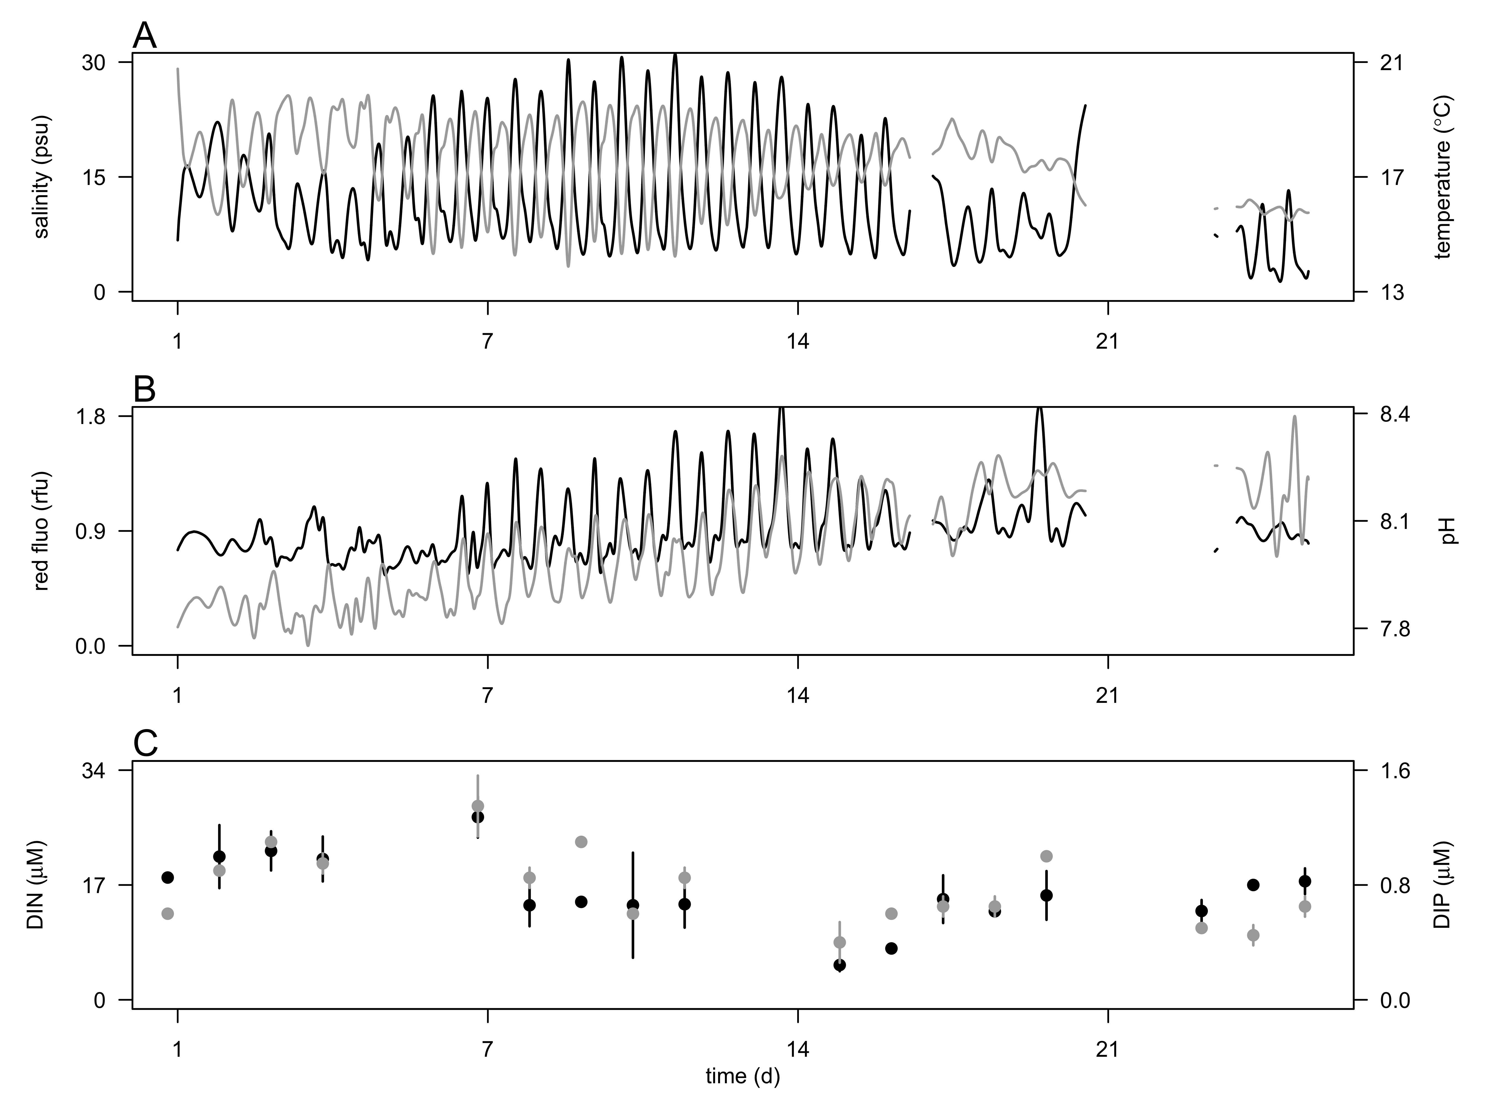

**Fig. 1** Hydrographic conditions during the 4 week-survey in the CRE at 2.4 m depth. A) Salinity (psu, black line) and temperature (ºC, grey line). Red fluorescence (black line, relative fluorescence unit, rfu and pH (grey line), and C) concentrations of dissolved inorganic nitrogen (DIN, µM, open circle) and phosphorus (DIP, µM, black circle). Vertical bars represent the ranges of the mean nutrient concentration.

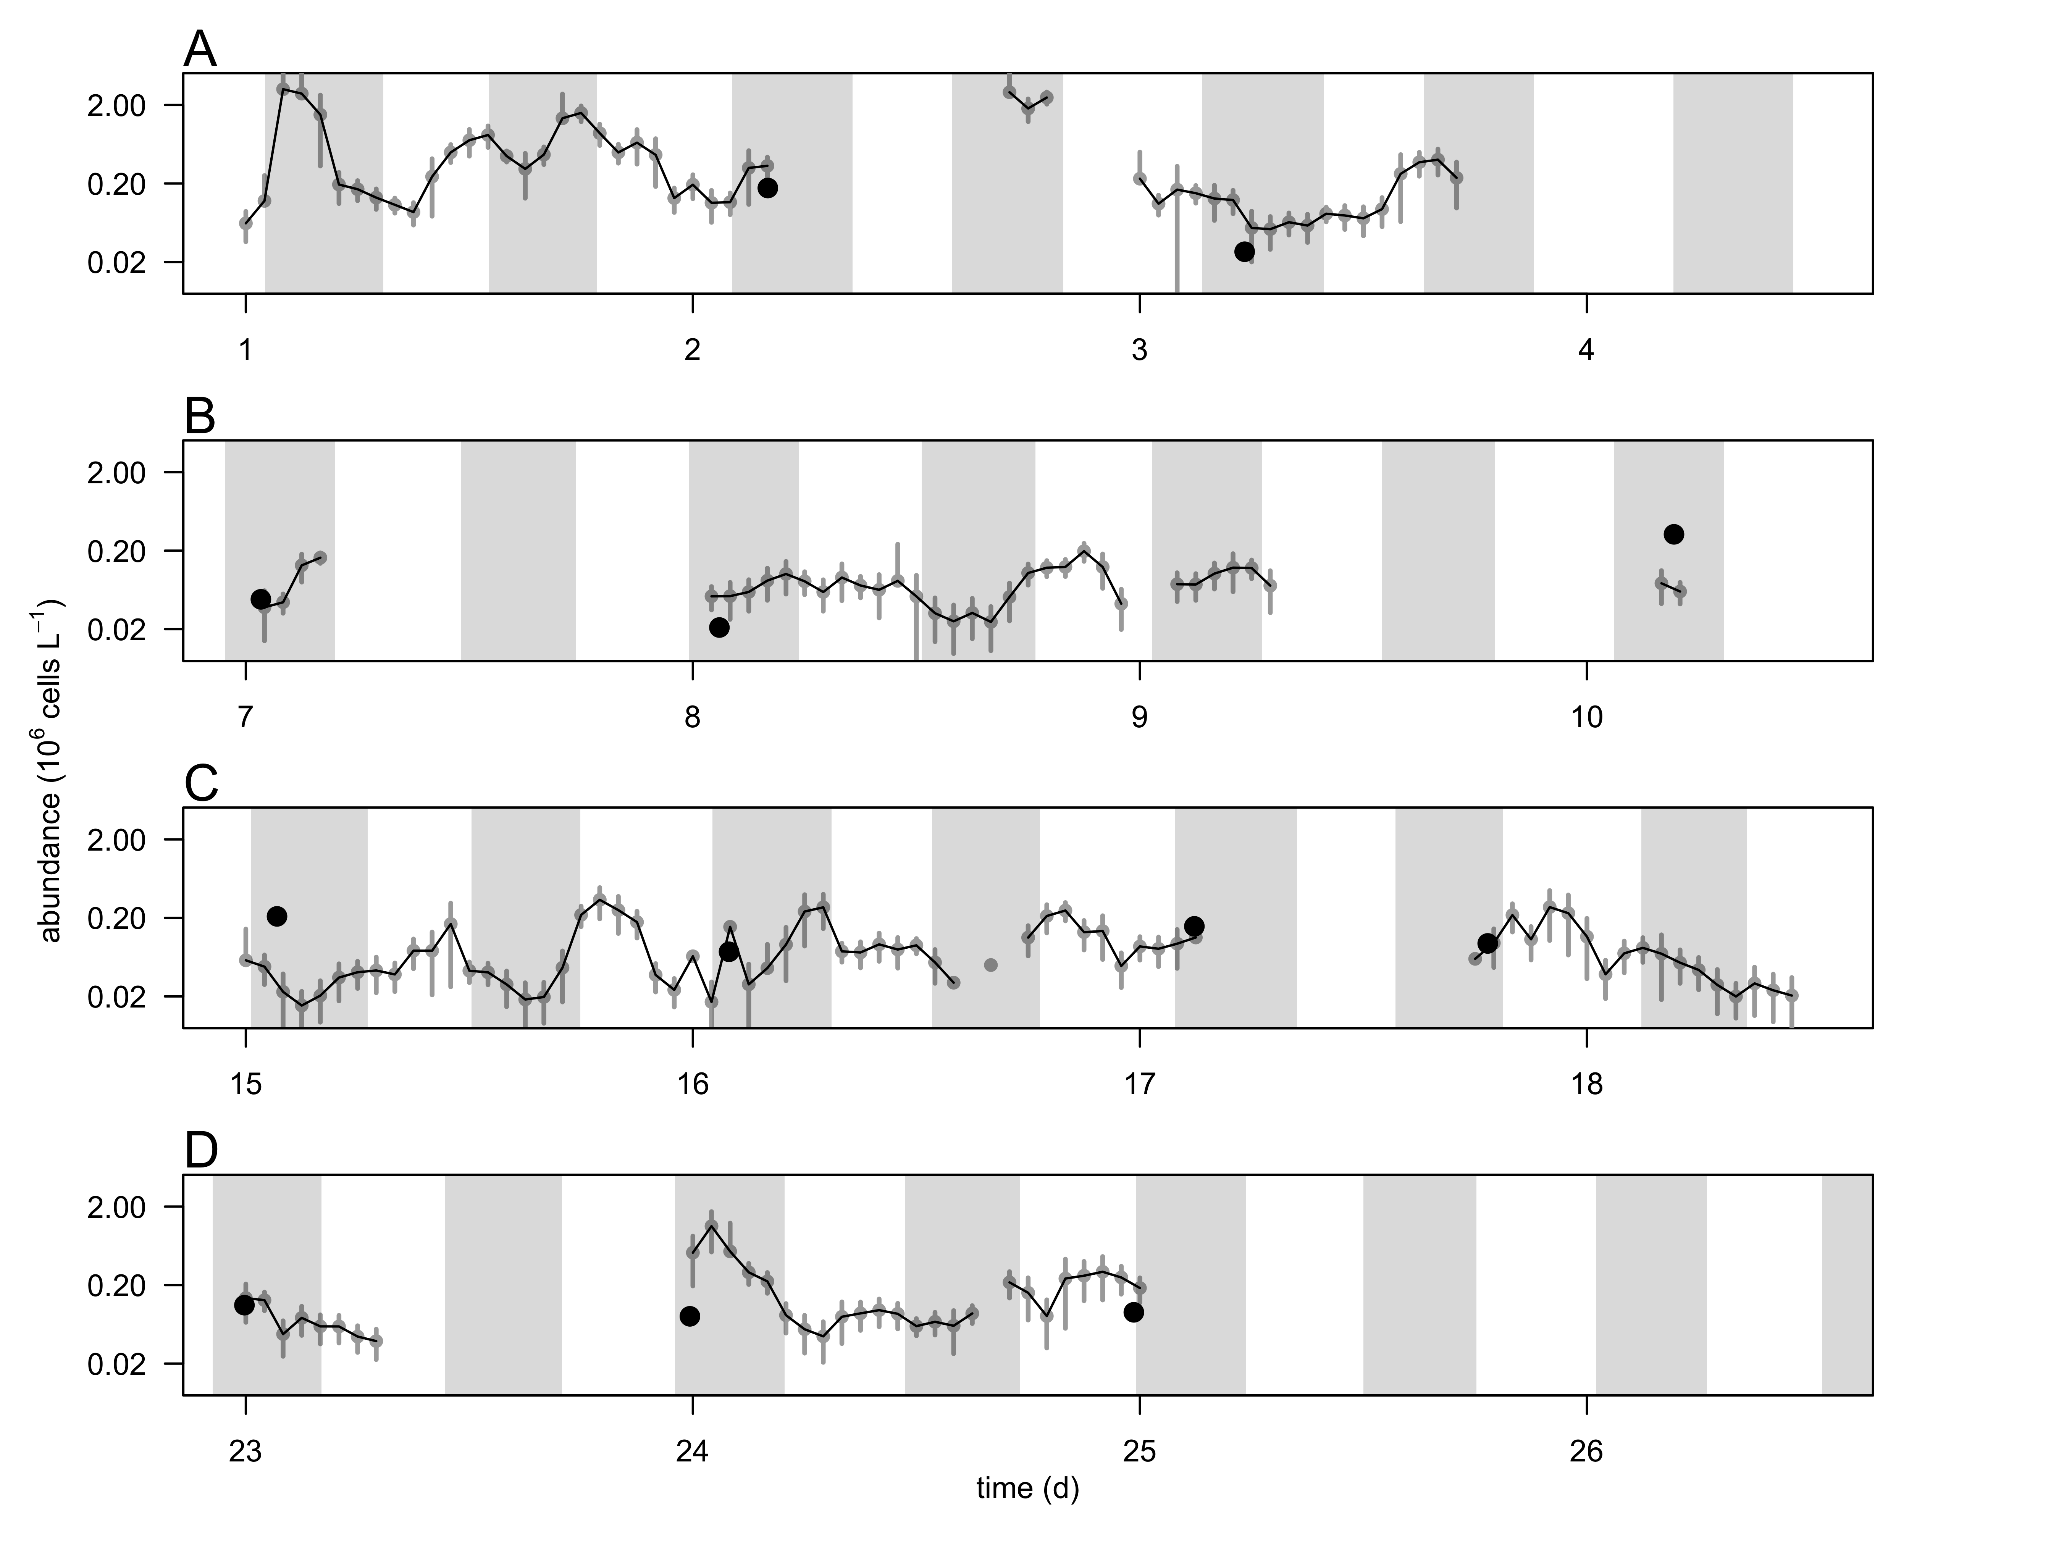

**Fig. 2** Hourly-averaged cell abundances of cryptophytes(grey circles and black line, 106 cells L-1) determined by continuous flow cytometry and abundance of *Mesodinium major* (black circles, 106 cells L-1) determined from discrete samples taken during the 4-week survey in the CRE (A-D). Vertical bars represent the standard deviation of the hourly-mean cell abundance (n=20). Grey regions represent flood tide. The discontinuity of the cryptophyte cell abundance was the result of frequent clogging of the flow cytometer due to high concentrations of suspended particle in the water.

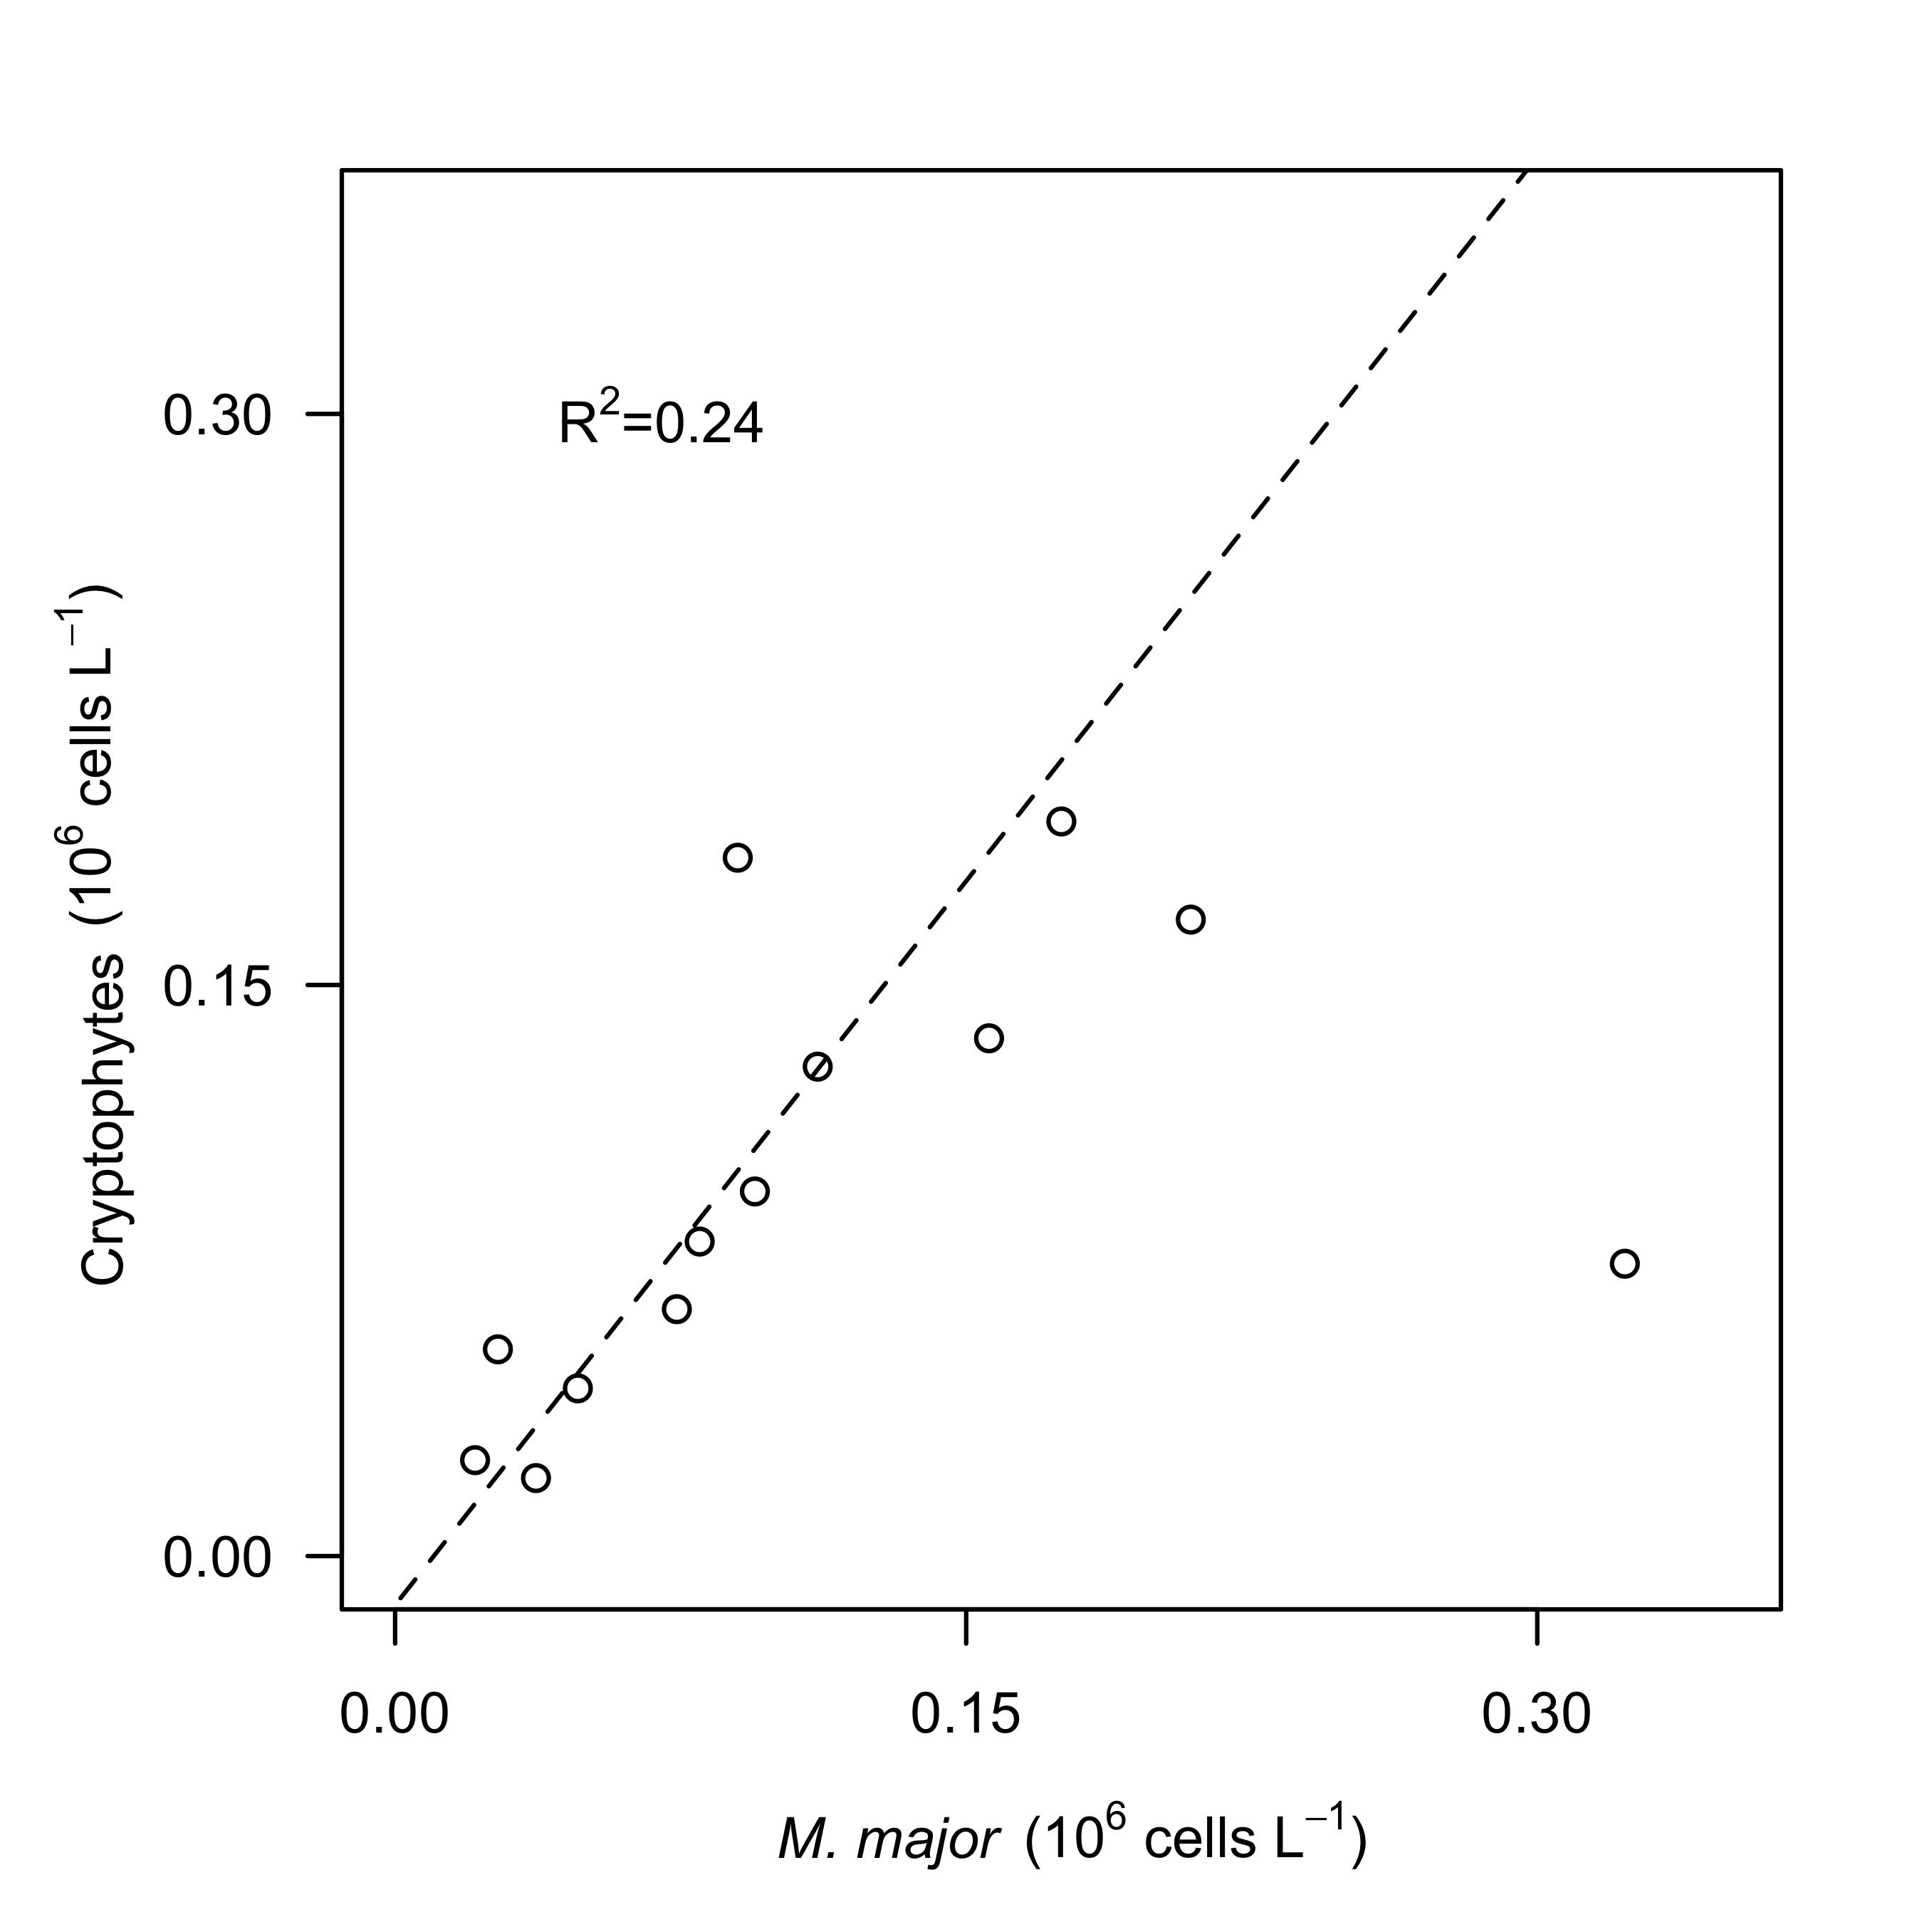

**Fig. 3.** Relationship between hourly-average cell abundances of cryptophytes (106 cells L-1)and *Mesodinium major* (106 cells L-1) during the survey in the Columbia River estuary. Dashed lines represent model II linear regression of plotted data and R2 represents the coefficient of determination.

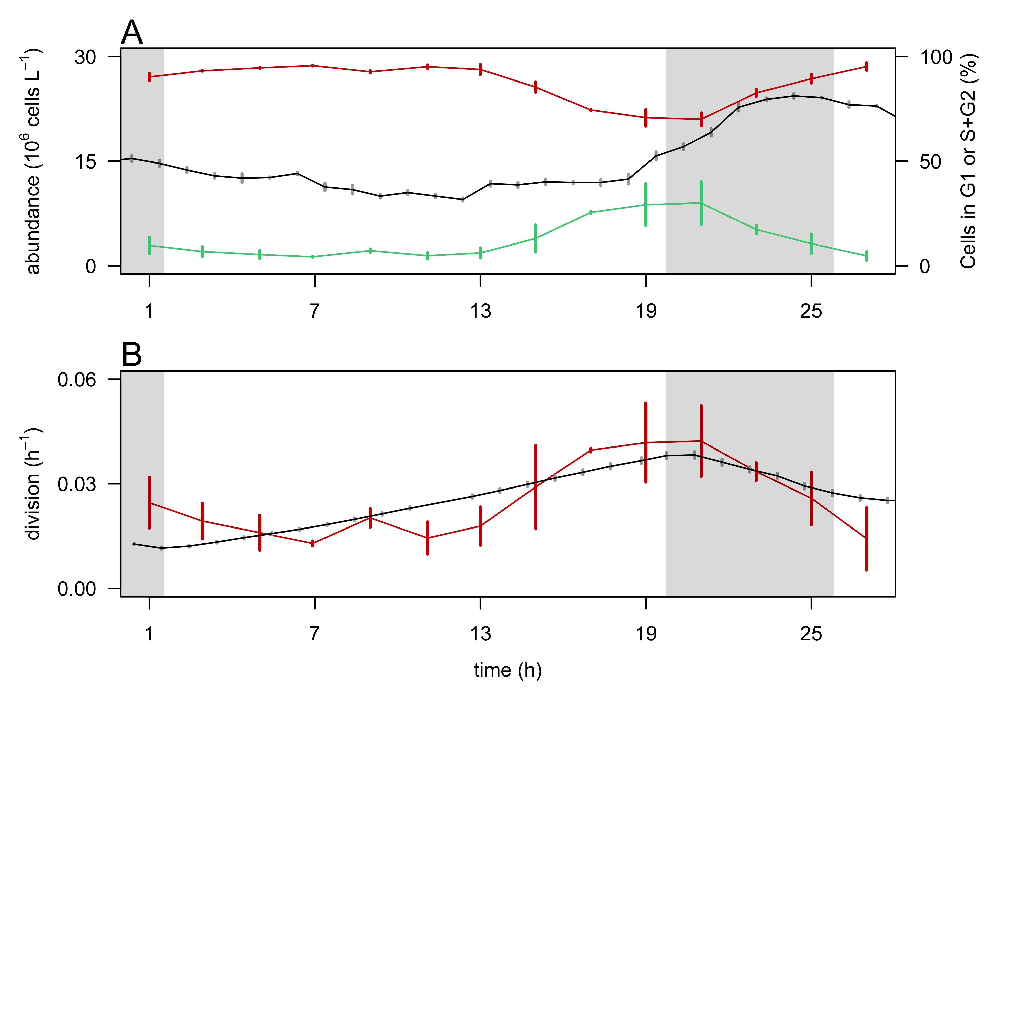

**Fig. 4.** Validation of the size-based division rate model with a cultured cryptophyte isolate during a 28-hr experiment.A) Hourly- averaged cell abundances of *Rhodomonas sp.* (106 cells L-1, black line) and percentage of cells in G1 (red line), and S+G2 (green line) phases. B) Hourly division rates (h-1) based on the relative proportions of cells in S+G2 phases (red line) and based on the size distribution (black line). The grey regions indicate night. Vertical bars represent standard deviations (n=20 for abundances, n=3 for the percent of cells in G1 and S+G2 phases, n=24 for the size-based division rates).

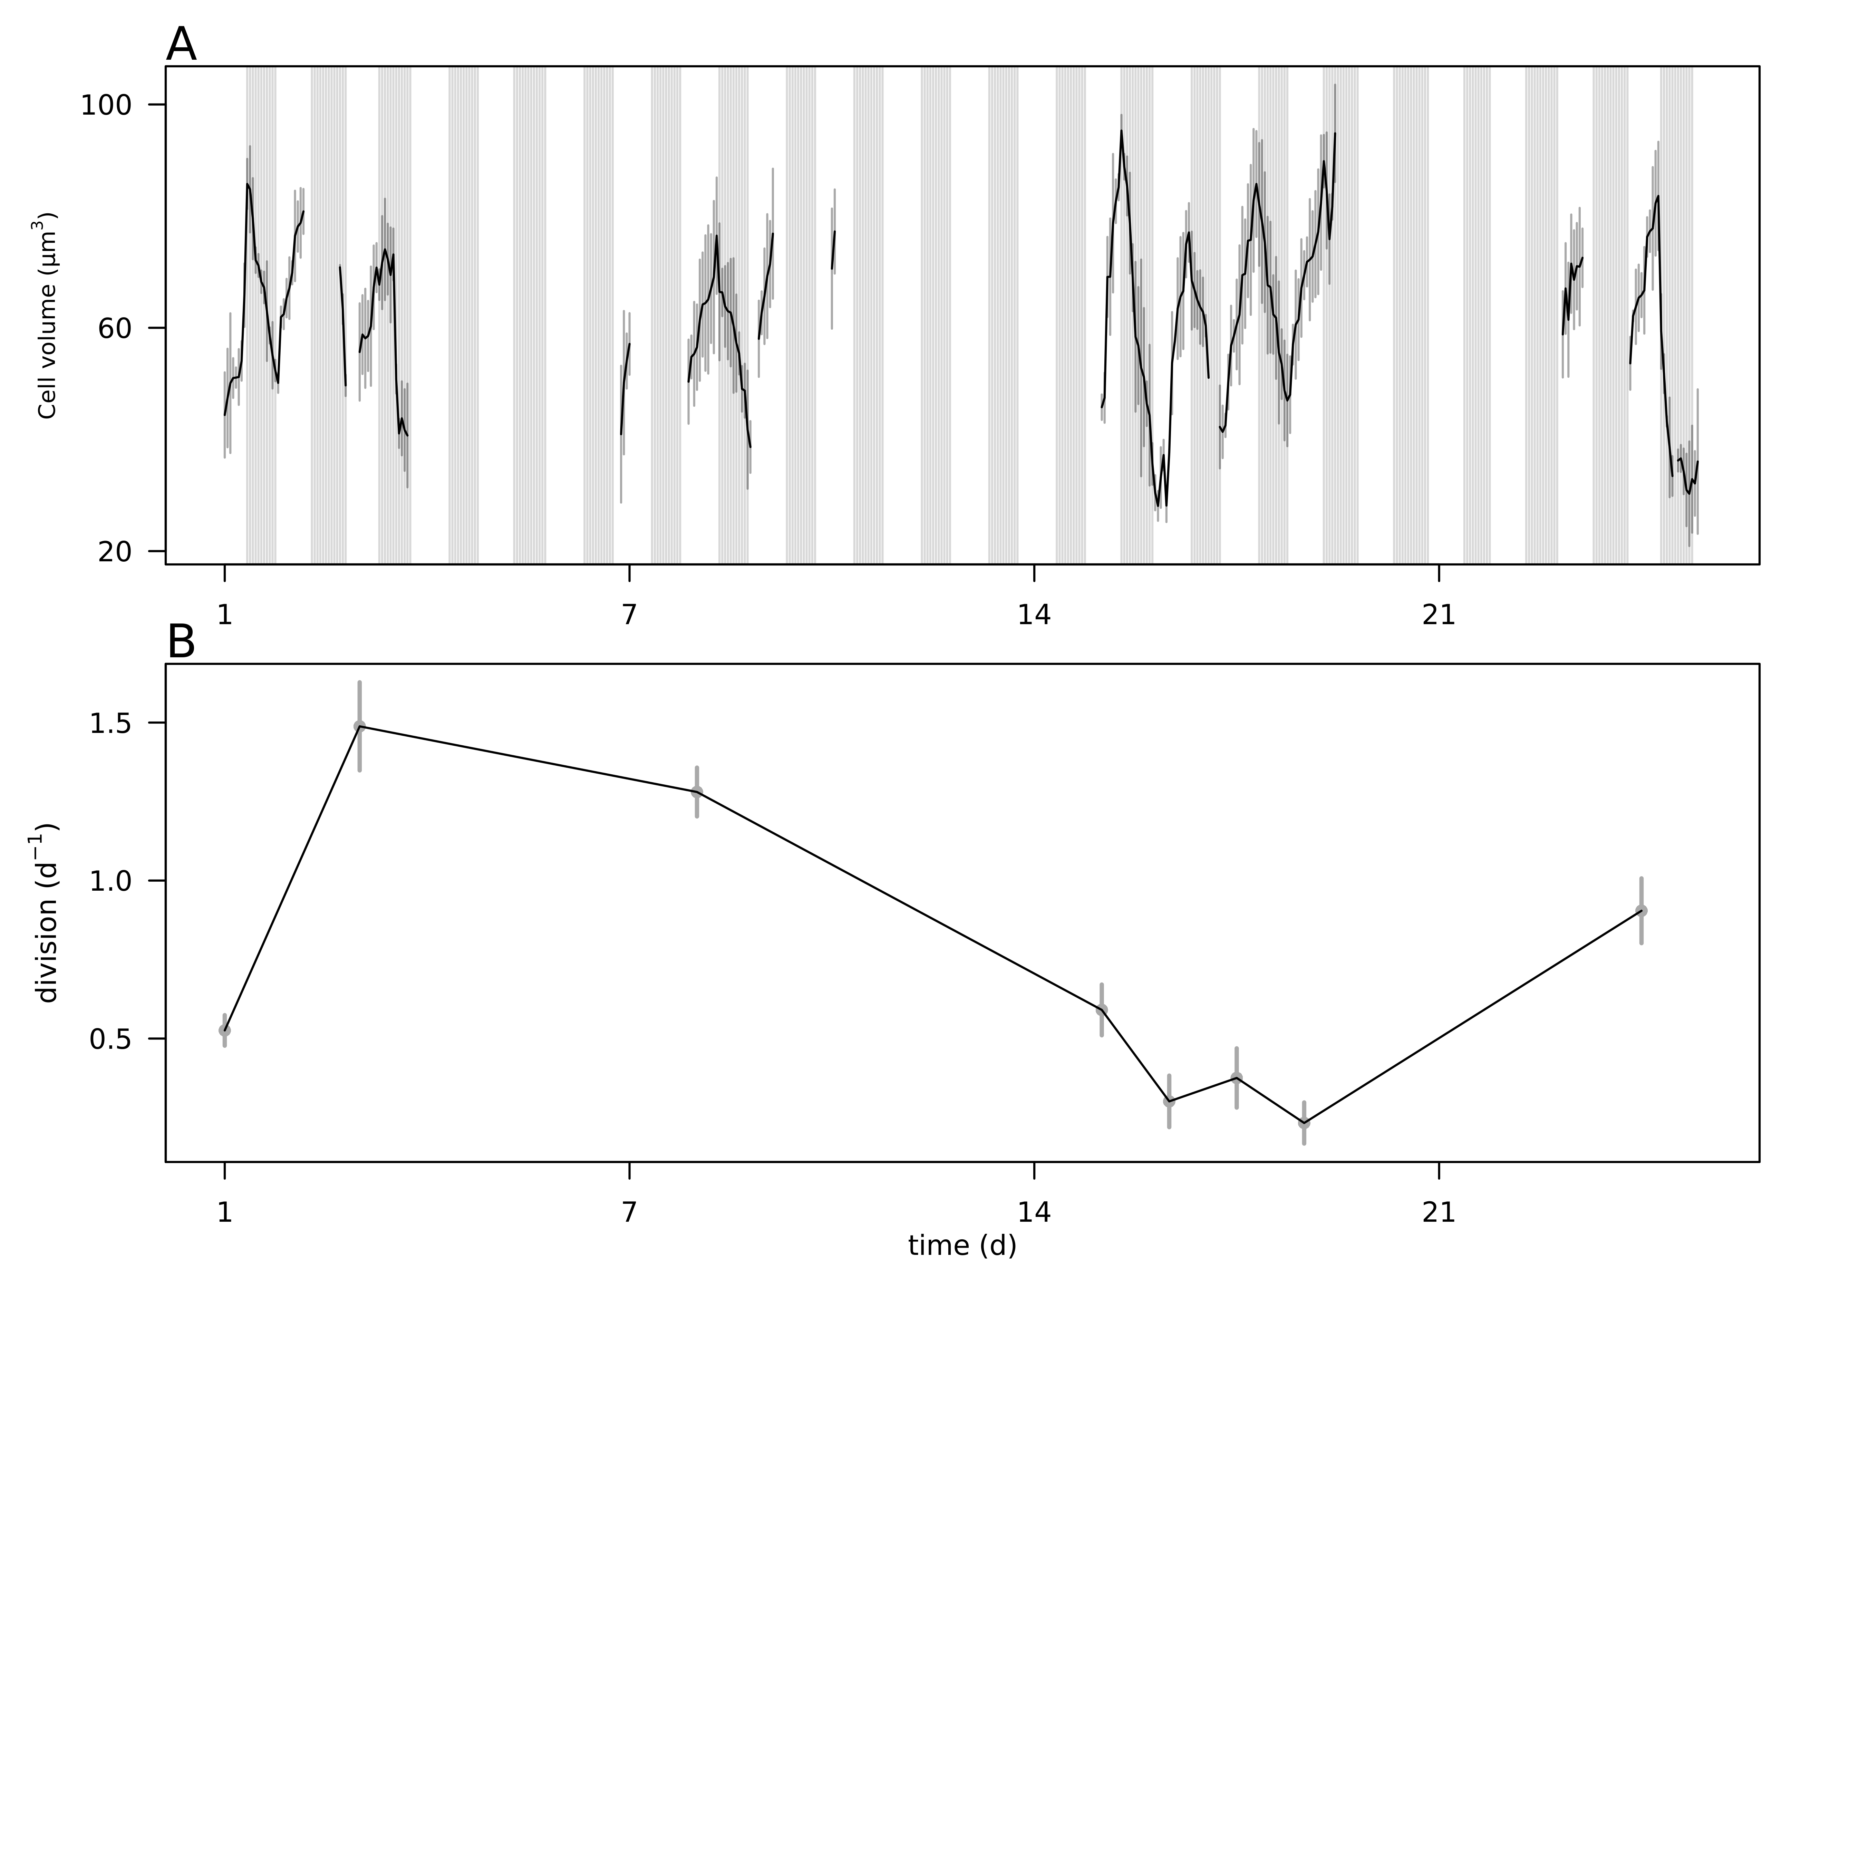

**Fig. 5.** A) Hourly-averaged cell volumes of *Teleaulax amphioxeia* (µm3) estimated by SeaFlow during the survey. Vertical grey bars represent the standard deviation of the hourly-mean cell volume. The grey regions indicate night. B) Daily rates of cell division (d-1) of *Teleaulax amphioxeia* during the survey in the CRE. Vertical bars represent the propagated standard error of the sum of hourly division rate estimates during each of the ten 24 h-period.

*The following supplement accompanies the article*

**Dynamics of *Teleaulax* cryptophytes during red water blooms in the Columbia River Estuary**

**Maria Hamilton, Joseph Nedoba, Katie Maxey, Rhonda Morales, Tawnya Peterson, Megan Schatz, Jarred Swalwell, Peter Zuber, E. Virginia Armbrust, Francois Ribalet \***

* Corresponding author: [ribalet@uw.edu](mailto:ribalet@uw.edu)

*Marine Ecology Progress Series XXX: XX–XX (201X)*

**Supplement.**

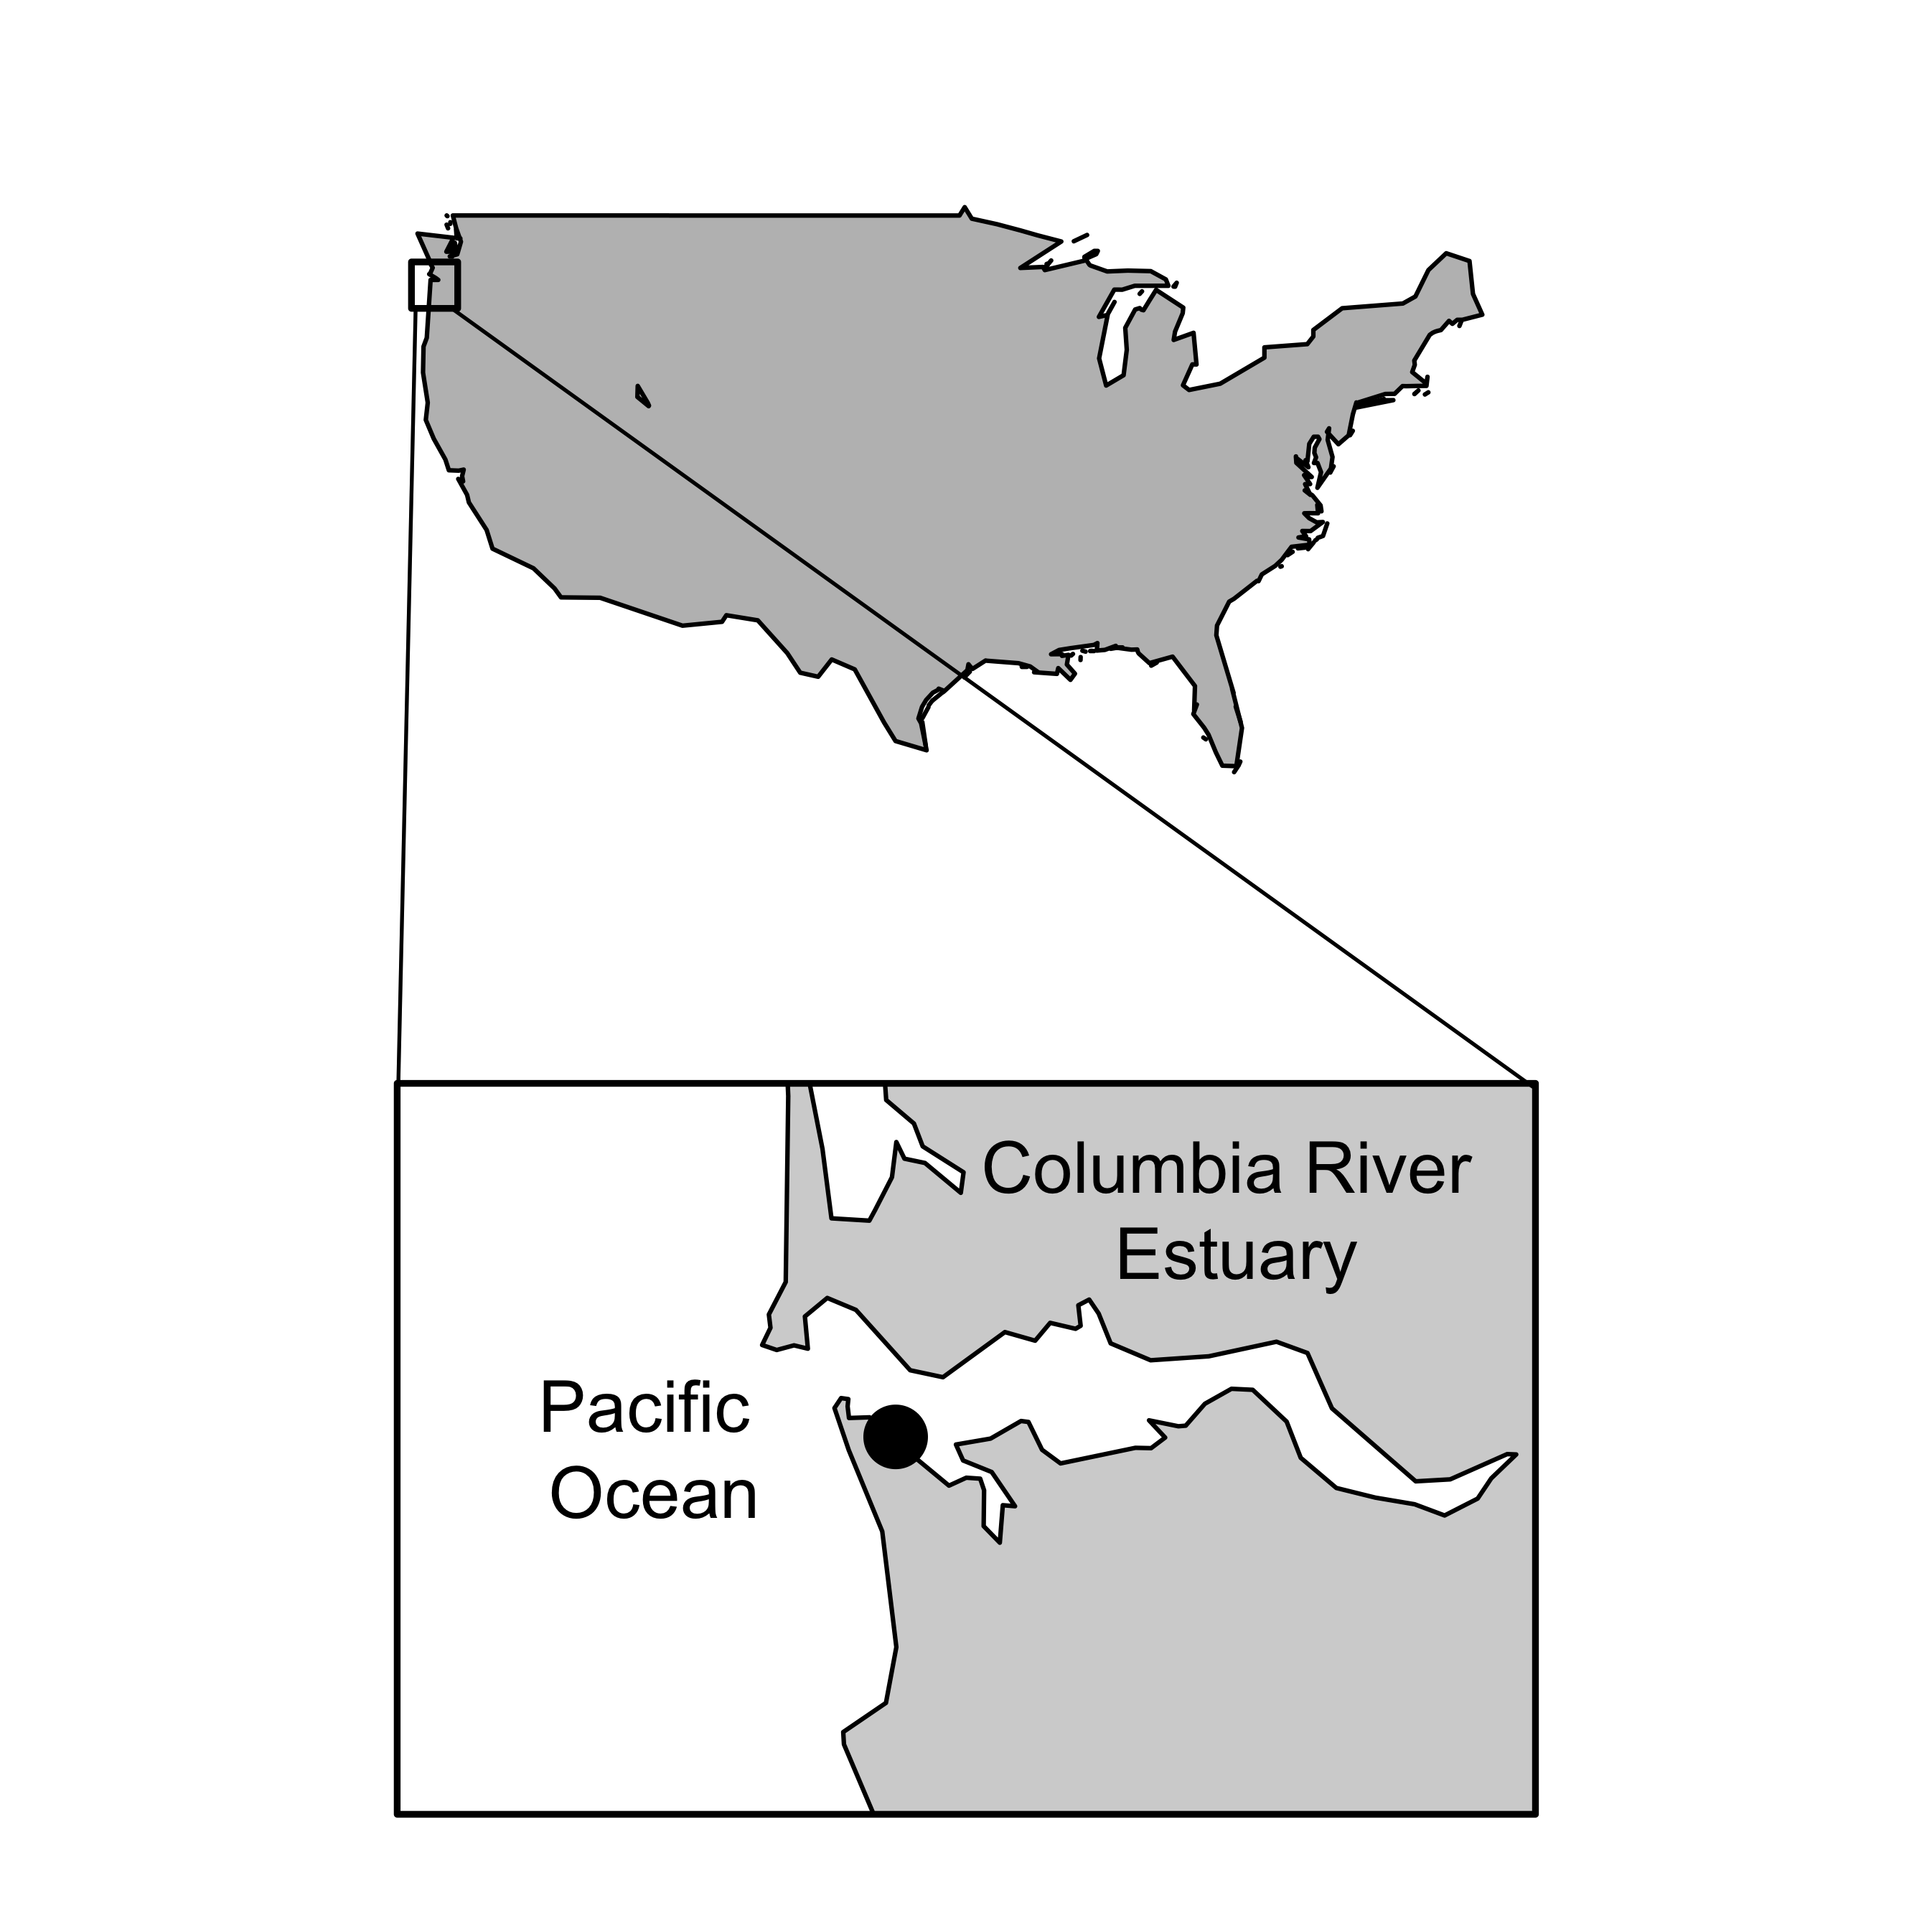

**Fig. S1** Map of the Columbia River Estuary with the sampling site location marked by the black dot.

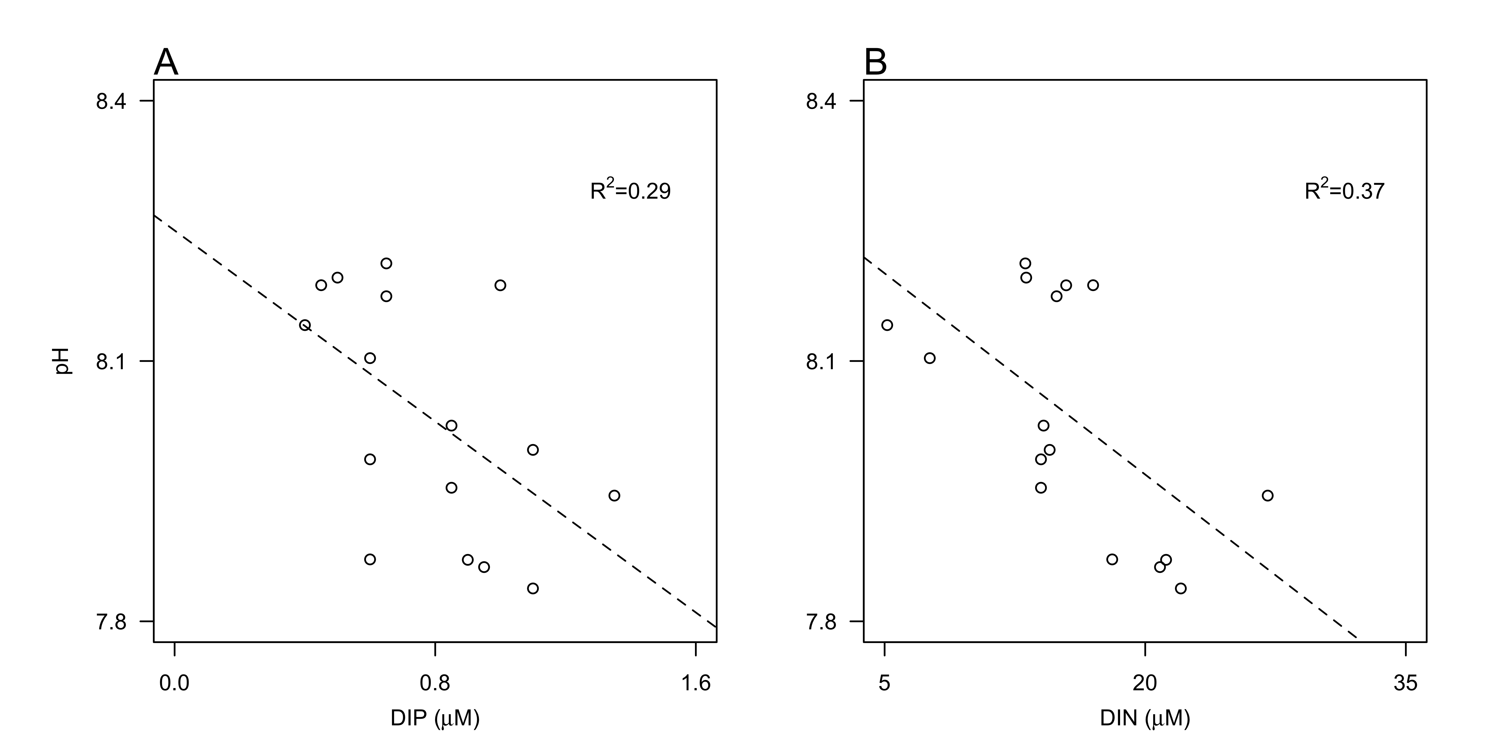

**Fig. S2** Relationship between pH and concentrations of A) dissolved inorganic phosphate (DIP, µM ), and ) dissolved inorganic nitrogen (DIN, as the sum of ammonium, nitrate and nitrite, µM). Dashed lines represent model II linear regression of plotted data and R2 represents the coefficient of determination.

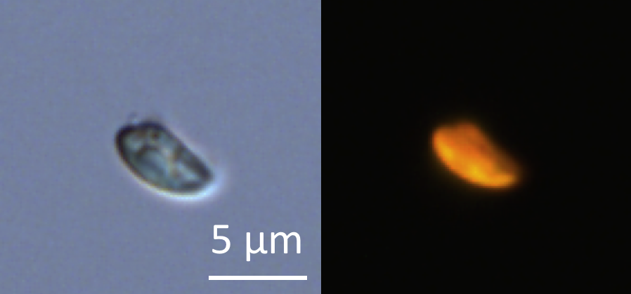

**Fig. S3.** Micrograph of glutaraldehyde-fixed *Teleaulax amphioxeia* cells using transmitted-light (A) and epifluorescence (B) microscopy after cell sorting by flow cytometry. Scale bar is 5 µm.

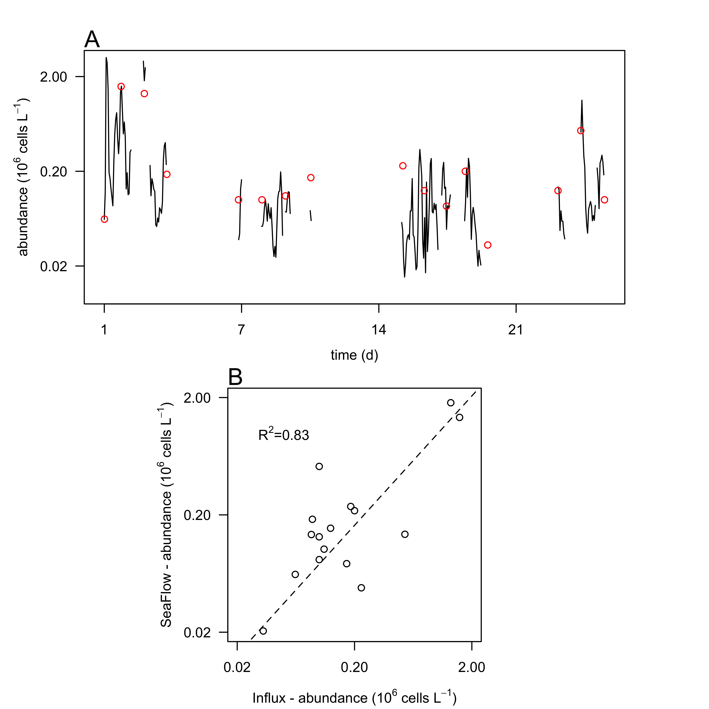

**Fig. S4.** Comparison of cell counts. A) Cell abundances of *Teleaulax amphioxeia* (106 cells L-1) during the survey measured with the SeaFlow instrument (black line) and measured with a BD Influx cell sorter (red circles). B) Correlation of cell abundances measured by the two instruments. Dashed lines represent model II linear regression of plotted data and R2 represents the coefficient of determination.

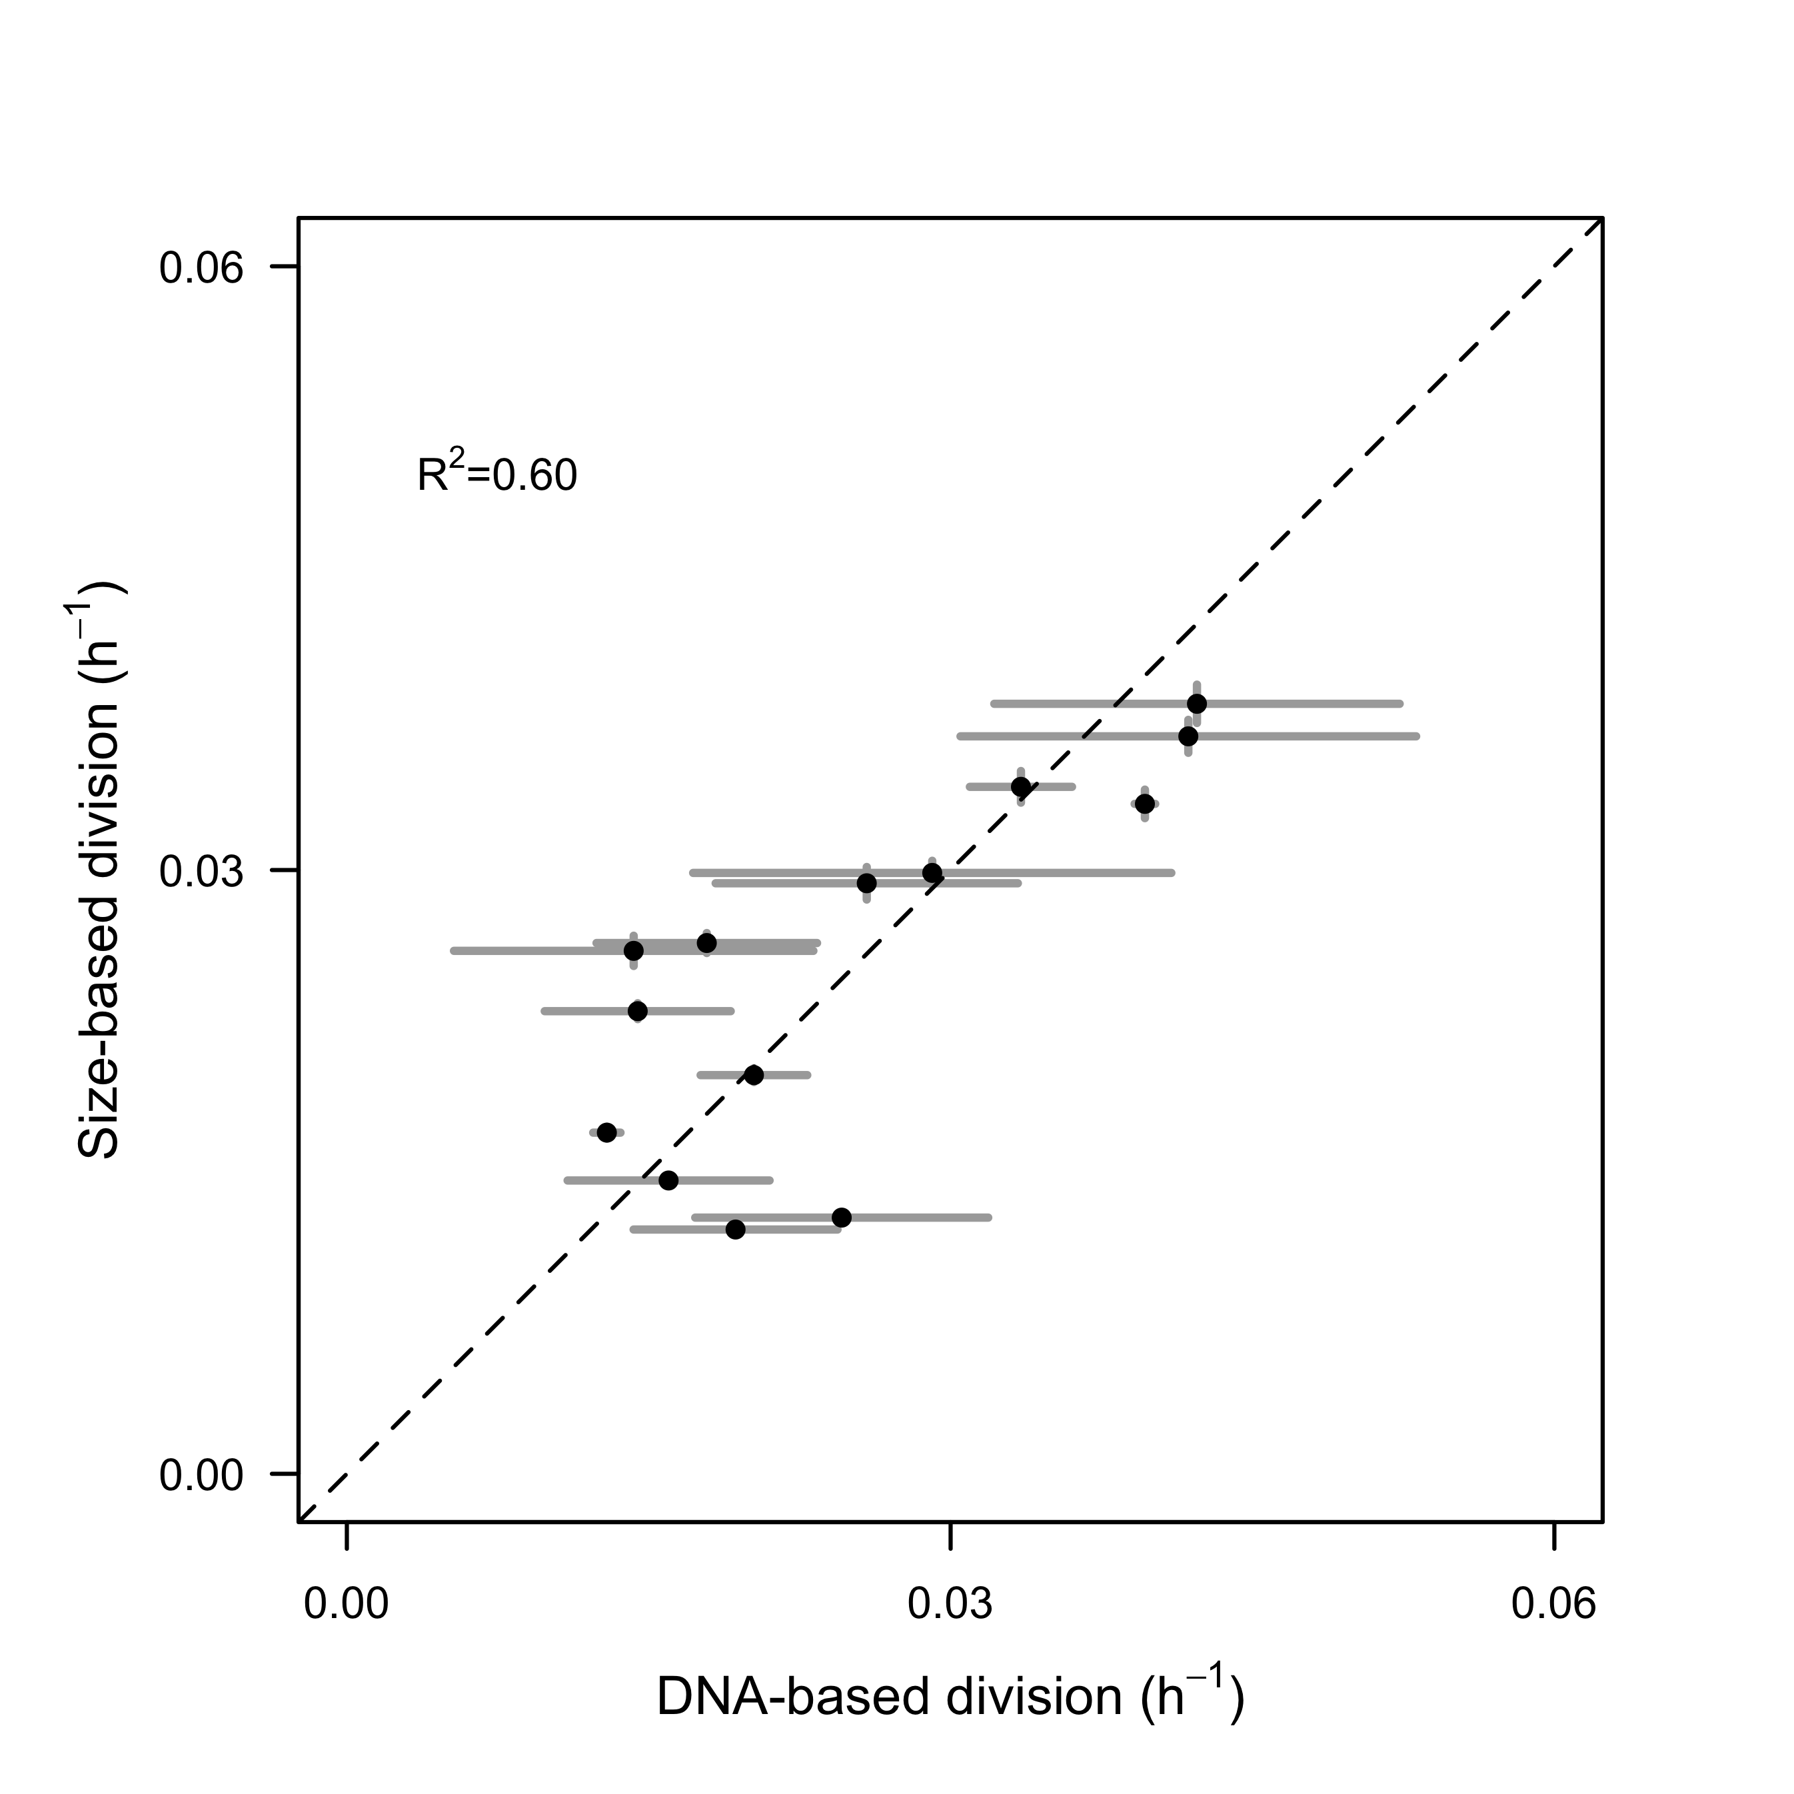

**Fig. S5.** Comparison of size-based division rate estimates (h-1) with DNA-based estimates of division rates (h-1) of *Rhodomonas* sp. in cultures over the course of 28-hr. Dashed lines represent model II linear regression of plotted data and R2 represents the coefficient of determination.

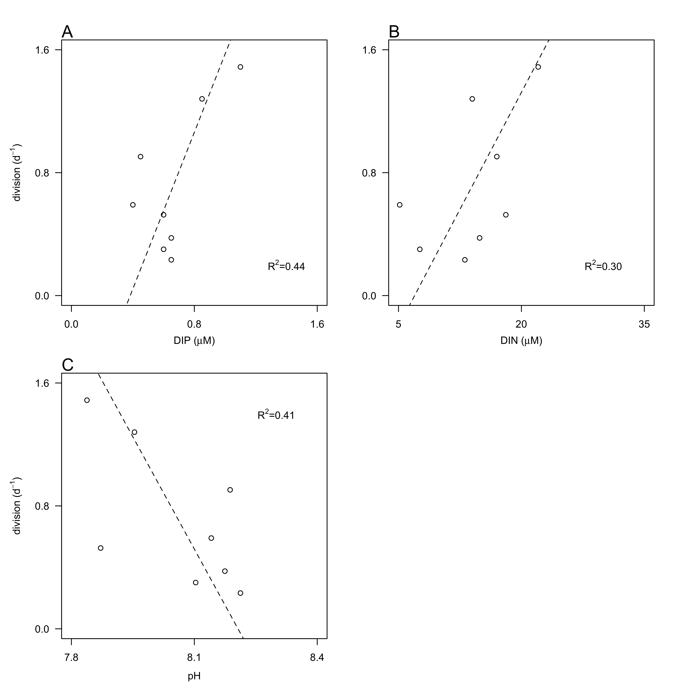

**Fig. S6.** Relationship between division rates (d-1) of *Teleaulax amphioxeia* with daily-averaged concentrations of dissolved inorganic A) phosphate (DIN, µM) and B) nitrogen (DIN, µM) and pH during the survey. Dashed lines represent model II linear regression of plotted data and R2 represents the coefficient of determination.